

Job Description

General Information

Job Title: Senior Marketing Data Analyst
Team: Data and Insights
Department: Database
Job Location: Andover or Home Based
Reports to: Head of Data and Insights
Level of Disclosure Check Required and Related Workforce:
Enhanced

Overall Purpose

Every day, around 300 people are diagnosed with macular disease. It’s the biggest cause of sight loss in the UK. Macular disease is cruel and isolating. It steals your sight, your independence, and your ability to do the things you love. There is only one way to Beat Macular Disease for good. We must fund more research now, until we find a cure, or find treatments that stop it in its tracks.

The Macular Society is working to deliver our ultimate ambition – to Beat Macular Disease for the next generation. We are determined to end the fear and isolation of macular disease with world-class research and the best advice and support.

As a Data Analyst, with a number of analytical tools at your disposal, you will be responsible for delivering reports, analysis and insight to support and inform both our fundraising and our services delivery and impact.

Day to day, you will:
- Work collaboratively with teams across the society
- Create visualisations, reports and models using tools such as Power BI
- Manage a reporting data warehouse, ensuring we have a single source of truth as a foundation for all our reporting.

The Senior Data Marketing Analyst reports into the Head of Data and Insights

Our Values

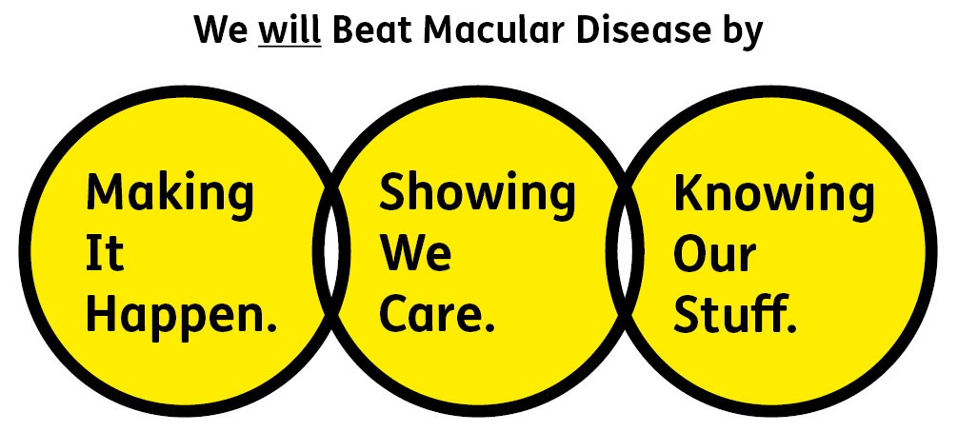

Making It Happen
We are Ambitious

Showing We Care
We are Supportive and Caring

Knowing Our Stuff
We have Integrity and we act Honestly

Key Accountabilities of the Role

- Actively support our value of ‘knowing our stuff’ by fostering a culture that values data and learns from it
- Produce quantitative data reports and dashboards to support all areas of our organisation in their data requirements
- Dig into and interrogate our data using dashboard analytics via the use of PowerBI, Microsoft Report Builder, and any other relevant tools
- Create accurate reports for internal and external use, analysing data to identify key issues, trends and areas for further exploration
- Empower teams by helping them better understand their data and how best to utilise it
- Maintain and manage a reporting data warehouse.

All employees will be expected to comply with Macular Society terms and conditions, rules, policies, procedures, codes of conduct, quality standards, authorisation processes, risk management policies etc. and relevant external regulations.

Competencies

- Supports and manages their team and colleagues
- Works well with others across the Macular Society
- Is committed to quality and service
- Delivers their objectives and core activities as required
- Takes responsibility for their own performance and development.

Person Specification

- Strong understanding of quantitative data analysis, including ability to summarise quantitative data, identify key data trends, describe and analyse weaknesses in data sources and present data visually
- Understanding of Dynamics 365 and Microsoft 365 Suite
- Expertise in data analysis using Excel and Business Intelligence tools such as Power BI
- Experience in building supportive relationships with people who are not well versed in data analysis so that they can become confident and competent in the use of said data
- Experience using databases/case management systems to organise and report on data; familiarity with the principles of databases and how they are structured
- Experience producing quantitative data reports to meet deadlines to high degrees of accuracy
- Experience managing a variety of demanding tasks simultaneously, successfully achieving deadlines through effective time and project management skills
- Excellent communication skills both oral and written
- Ability to communicate with users at all levels
- Ability to produce clear documentation
- Ability to present data in a clear and compelling way, using graphical representations and data visualisations
- A team player, flexible and willing to work with and support colleagues across the Society.

Desirable:

- Experience with Advanced NG (Care), or analysing data from CRM systems
- Understanding of data warehousing
- Ability to extract data for analysis using SQL Server
- Understanding of data protection and data security, including relevant UK legislation and how it might influence our work.

Eligibility to work in the UK:
Proof of identity and eligibility to work in the UK.

Volunteering:
From time to time you may be asked to support / volunteer your time (TOIL available) at Macular Society events that take place outside of normal working hours.

Safeguarding:
The Macular Society is committed to safeguarding and promoting the welfare of all children, young people and vulnerable adults with whom we work. We expect all of our employees and volunteers to demonstrate this commitment.

The post holder is required to carry out other such duties as may
reasonably be required, commensurate with the grade of this post. All
employees will be expected to excel in being supporter centric,
demonstrate advocacy for the Macular Society at all times and be a fundraiser.
This job profile is accurate as at the date shown below. In consultation
with the post holder it is liable to variation by management to reflect
or anticipate changes in or to the role.

Annual leave: 26 days plus bank holidays plus an extra day after 1 years’ service (pro rata for part time)
Based: Home/Andover
Contract Type: Permanent

DATE OF EVALUATION: February 2026

