Job description

Job title: Trusts & Philanthropy Officer
Team: Trusts & Philanthropy
Department: Fundraising
Job location: Hybrid approach with working from home and 2 days a week in the Andover office.
Reports to: Head of Trusts & Philanthropy

Overall purpose
Macular disease is the biggest cause of sight loss in the UK, with around 300 people diagnosed every day. The Macular Society is the only charity determined to beat the fear and isolation of macular disease with world class research, and the best advice and support.

To support people affected by macular disease we provide a range of advice, information and services. Our pioneering research programme is focused on finding new treatments and a cure to Beat Macular Disease forever.

Role Overview
We are looking for an organised and enthusiastic Trust and Philanthropy Officer to support us to grow income and beat macular disease.
Working with a passionate and ambitious team you will contribute to the annual team target of c£1million. You will help achieve this by managing a portfolio of prospects and developing compelling applications and reports for funders.
More than just a fundraising role, this is a unique opportunity to make a meaningful impact for people affected by macular disease.

Organisational chart

The Trusts & Philanthropy Officer reports to the Trusts & Philanthropy Manager.

Our values
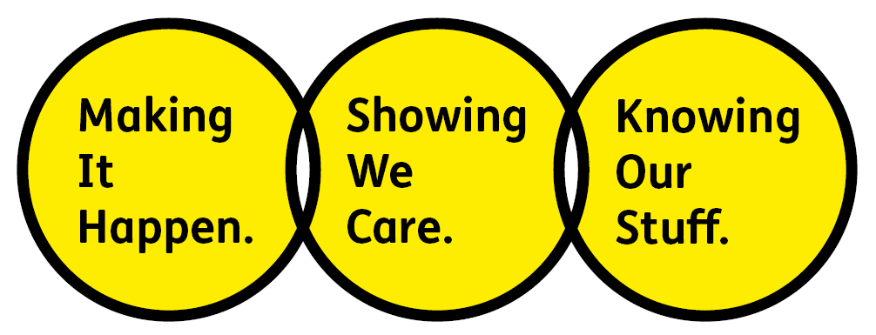
We will beat macular disease by…

Making It Happen - we are Ambitious

Showing We Care - we are Supportive and Caring
- Knowing Our Stuff - we have Integrity and we act Honestly

About the role
Working as part of a passionate and ambitious team you will:
- Develop excellent and persuasive funder proposals (mainly £10k and under), using accurate and impactful project information collected from relevant teams.
- Produce progress reports to meet funder requirements, meeting with relevant staff to get project and budget updates.
- Deliver exemplar and creative stewardship to donors, which responds to individual needs, engages trustees and inspires continued support.
- Support prospect research using fundraising research resources to identify and cultivate prospective funders.
- Support the identification of trustees within your portfolio of Trusts with the potential to give individually and deliver stewardship to inspire and expand their commitments as mid-level and major donors.
- Ensure the CRM (Dynamics) is kept up to date, accurately recording communications with funders, coding income and logging actions.
- Lead on the administration of the bi-annual small trust mailing.
- Support our digital transformation project, feeding back on trusts and philanthropy requirements to inform transition to a new CRM in 2027.
- Support general and office administration for the Trusts and Philanthropy team, for example, opening post, coordinating mailings, scanning communications and processing income.
- Support the Trusts and Philanthropy team when required with specific projects and events and coordinating the work of interns and volunteers.
- Keep up to date with best practice in fundraising and comply with relevant legislation.
All employees are expected to comply with Macular Society terms and conditions, rules, policies, procedures, codes of conduct, quality standards, authorisation processes, risk management policies etc. and relevant external regulations.
About you
- You will be committed to equality, diversity and inclusion in all aspects of our work.
- Have an open and collaborative approach to work. Helping us to achieve our Knowing Our Stuff value by working with integrity and making informed decisions to support us to be the best we can be to beat macular disease.
- Be able to act with empathy, providing a caring, approachable and supportive environment for all – we Show We Care by listening to each other and working together.
- Be ambitious in your approach to help Make Things Happen, we are progressive yet supportive, and brave in our actions to make the progress that is needed to beat macular disease.
- Be happy to work in an organisation that puts those we support first, advocate for the Macular Society at all times, and be comfortable that all members of the team are part of our fundraising culture.

Person specification
Skills, experience and knowledge required for the role:

Essential
- Excellent written communication skills with an ability to write to a deadline
- Strong organisational and administrative skills including budgeting and excellent attention to detail
- Good interpersonal skills with the ability to maintain relationships at all levels.
- Ability to work proactively under own initiative
- A team player with a flexible approach, willing to work with and support colleagues across the organisation
- IT skills including Word, Excel, PowerPoint, Outlook, databases

Desirable
- Experience in four/five figure fundraising from grant making trusts
- Knowledge of fundraising research sources and methodologies
- Knowledge of and empathy with issues relating to sight loss
- Working for a charity
- Experience of using Microsoft Dynamics 365 database

Volunteering
From time to time you may be asked to support / volunteer your time (TOIL available) at Macular Society events that take place outside of normal working hours.

Safeguarding
The Macular Society is committed to safeguarding and promoting the welfare of all children, young people and vulnerable adults with whom we work. We expect all of our employees and volunteers to demonstrate this commitment.
You are required to carry out other such duties as may reasonably be required, relevant to the role.
This job description is accurate as at the date shown below. In consultation with you it is liable to variation by the Macular Society to reflect or anticipate changes in or to the role.

Annual leave: 26 days plus bank holidays (pro rata for part time)
Based: Hybrid, Andover office 2 days, homeworking 3 days.
Contract Type: Permanent / Full time
Date of evaluation: October 2026

