Job description

Job title: Patient Information Manager
Team: Services
Department: Services
Job location: Andover or Home Based
Reports to: Director of Services

Overall purpose
Macular disease is the biggest cause of sight loss in the UK, with around 300 people diagnosed every day. The Macular Society is the only charity determined to beat the fear and isolation of macular disease with world class research, and the best advice and support.

To support people affected by macular disease now, the Macular Society provides a range of support, information and services. Our research programme is focused on finding new treatments and a cure to Beat Macular Disease forever.

Organisational chart

The Patient information manager reports to the Director of services. Also reporting to the Director of services are the Head of community networks, Counselling service manager, Information and advice manager, Services innovation manager and Programmes manager. Please note this is an interim structure and is expected to change in 6-12 months’ time.

Our values
We will Beat Macular Disease by…

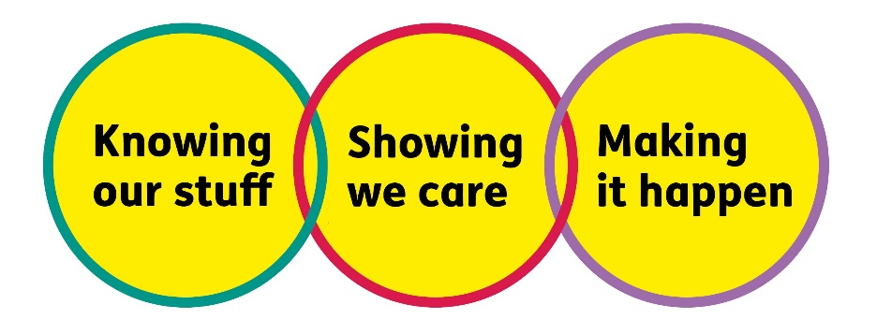

Making It Happen - we are Ambitious

Showing We Care - we are Supportive and Caring
- Knowing Our Stuff - we have Integrity and we act Honestly

About the role

The Patient information manager is responsible for producing excellent quality patient information materials which are engaging and enable people with macular disease to understand their condition, what treatment options are available, and how they can live well with sight loss.
The Patient information manager will ensure that our full range of information, both online and in print, is evidence based, reliable and up to date. They will ensure it reflects current clinical best practice and that it is reviewed by relevant experts to ensure high quality.
They will ensure that our content is accessible to all, including people with sight loss or with low health literacy, translating complex scientific and medical information into engaging and understandable content.
The role will include creating new information products as well as updating existing ones, ensuring that all our new and existing information meets user needs and is wanted and valued by our service users.

Key accountabilities of the role
- Produce high quality, engaging and interesting patient information materials that are accurate and up to date, including writing content and commissioning images, audio and/or video as required.
- Contribute patient information content to the annual conference, podcasts, and monthly My Macular and Me webinars.
- Manage the regular review and updating of our information materials, ensuring clinical and scientific quality.
- Feed into content development processes, identifying where quality could be improved or time saved and continually improving our ways of working.
- Seek and use input from people living with macular disease to inform our information offer and ensure it is meeting their needs, creating new content where necessary.
- Take the lead on ensuring our continued compliance with, and accreditation by, Patient Information Forum as a Trusted Information Creator.
- Lead evaluation of our patient information offer, gathering feedback and making changes to improve its quality.
- Produce content that is highly tailored to the channel of its delivery, ensuring that SEO, accessibility and other best practice recommendations are implemented, taking guidance from the Digital team.
- Collaborate with the Digital team on digital strategy and content plan.
- Create user journeys around content and services that allow and promote deeper engagement, in collaboration with the engagement and Digital teams.
- Collaborate with Helpline team and other service user-facing teams to ensure that messaging and advice is consistent between teams and that insight from our other services is used to improve our information offer.
- Liaise with expert reviewers (internal and external, as relevant) to ensure good quality control and scientific and clinical accuracy.
- In collaboration with Research team, carry out literature reviews and searches to ensure your technical knowledge remains up to date.
- Manage content workflows, ensuring drafts are appropriately reviewed by relevant teams internally, and that content and creative is approved, published and distributed efficiently.
- Edit patient information pages on the website, using content management system and ensuring all publication processes are followed correctly.
- Work with others in Services to develop plans for engagement with healthcare professional audiences, and support with content as required.
- Edit and proof-read materials from other areas of the organisation where it contains any patient information, acting as an expert reviewer to them.

All our team members are expected to comply with Macular Society terms and conditions, rules, policies, procedures, codes of conduct, quality standards, authorisation processes, risk management policies and relevant external regulations.

About you
1. You will be committed to equality, diversity and inclusion in all aspects of our work.
2. Have an open and collaborative approach to work, helping us to achieve our Knowing our stuff value by working with integrity, making informed decisions to be the best we can be to Beat Macular Disease.
3. Be able to act with empathy, we provide a caring, approachable and supportive environment for all – we Show We Care by listening to each other and working together.
4. Be ambitious in your approach to help Make Things Happen, we are progressive yet supportive, and brave in our actions to make the progress that is needed to Beat Macular Disease.
5. Be happy to work in an organisation that puts those we support first, advocate for the Macular Society at all times, and be comfortable that all members of the team are fundraisers.

Specifically for this role you will have:
Knowing Our Stuff
- Experience of creating quality-assured written patient information, translating complex scientific information into understandable language.
- Knowledge of sight loss and how people can live well with visual impairments, or a desire to learn.
- Extensive experience of tailoring content for different audiences and channels, including print, email and digital information.
- Excellent knowledge of best practice in digital health and patient information, including accessibility, SEO, and user journeys.
- Experience of gathering and using user feedback and input to ensure content meets service user needs, co-creating information materials with users.
- Ability to search, understand and summarise scientific information and research papers.
- Excellent writing, copy-editing and proofreading skills in English.
- Strong communicator, able to flex style and influence others.
- Strong attention to detail, and a high level of accuracy.
- Understanding of, and experience with content workflows and all the necessary stages of medical and health content production.
- A credible professional with good influencing skills and a can do and hands on approach.
- Desire to continuously learn and build specialist knowledge.
- Ability to act as an advisor to others, sharing knowledge in a supportive and constructive manner.

Making It Happen
- Ability to research topics, identify key information and communicate it effectively.
- Excellent project delivery skills and ability to manage diverse and demanding workloads.
- Ability to work independently under own initiative and cooperatively as part of a team.
- Ability to multitask and prioritise multiple projects and work streams.
- Strong IT skills including Word, Excel, PowerPoint, Outlook
- Experience of content-related software systems, including CMS and content workflow management tools.

Showing We Care
- Understanding of the information and support needs of people with macular disease, families and carers at all stages of their journey.
- Understanding and empathy for people living with sight loss, and desire to make a difference.
- Ability to develop and maintain excellent working relationships, seeking diverse points of view and feeding back constructively where needed.
- Excellent team working and collaborative working skills and the ability to develop effective partnerships.
- Commitment to high standards in all areas of work.

Eligibility to work in the UK:
Proof of identity and eligibility to work in the UK. Enhanced DBS check required for this role.

Volunteering:
From time to time you may be asked to support / volunteer your time (TOIL available) at Macular Society events that take place outside of normal working hours.

Safeguarding:
The Macular Society is committed to safeguarding and promoting the welfare of all children, young people and vulnerable adults with whom we work. We expect all of our employees and volunteers to demonstrate this commitment.
You are required to carry out other such duties as may reasonably be required, relevant to the role.
This job description is accurate as at the date shown below. In consultation with you it is liable to variation by the Macular Society to reflect or anticipate changes in or to the role.

Annual leave: 26 days plus bank holidays (pro rata for part time)
Based: Hybrid
Contract Type: Permanent, Full Time (flexible working considered)

Date of evaluation: Nov 2025

