Job description

General information

Job title: Head of Services Development
Team: Services team
Department:
Job location: Andover or Home Based
Reports to: Director of Services
Number of direct reports: 4
Level of disclosure check required and related workforce: Enhanced

Overall purpose
Every day, around 300 people are diagnosed with macular disease. It’s the biggest cause of sight loss in the UK. Macular disease is cruel and isolating. It steals your sight, your independence, and your ability to do the things you love. There is only one way to Beat Macular Disease for good.
The Macular Society is working to deliver our ultimate ambition – to Beat Macular Disease for the next generation. We are determined to end the fear and isolation of macular disease with world-class research and the best advice and support.

Purpose of the role
The purpose of the role is to contribute and deliver on our strategy for development of the Macular Society’s information, support and education services, ensuring people affected by macular disease receive high quality emotional and practical support to beat the impact of it.
One of our three key strategic objectives is - Providing the best advice and support:
- We will provide the best quality advice, information and support for people with macular disease because evidence shows that better informed patients are less likely to lose vision unnecessarily.
- We will understand more about the people who are affected by macular disease, how they feel, what support they need, where and when.
- We will ensure our services meet those needs. This means continuing to develop a wider portfolio of activities, delivered in a broader variety of ways, to reach diverse communities. Everyone who comes to the Macular Society will find something of benefit.
- We will engage with health and care professionals who work with people affected by macular disease. We will raise awareness of the need for better emotional and practical support for people affected by macular disease. We will encourage referral to our specialist services so that we can support more people when and how they need us.

Organisational chart

The Head of Services Development reports into the Director of Services. The Head of Services Development will line manage the Programmes Manager (who delivers our befriending, Connect by Tech and Skills for Seeing (rehabilitation) services, Advice and Information Services Manager, Counselling Services Manager, and Manager, Working Age and Young People.
The Head of Services Development will also work closely with:
- Head of Regions
- Volunteer Manager

Our values

We will beat macular disease by…

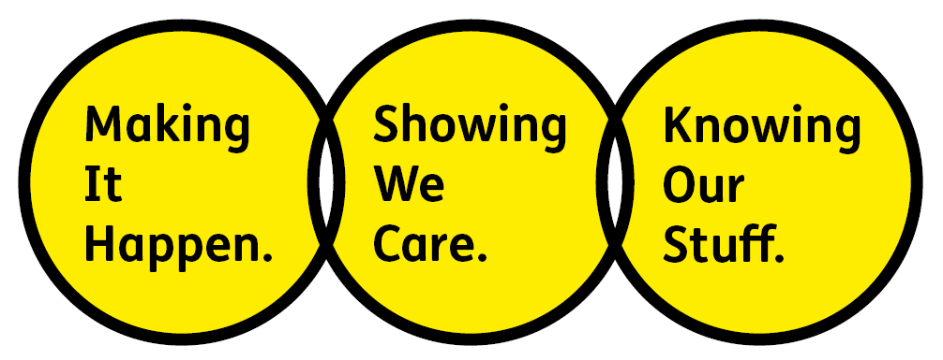

Showing We Care - we are Supportive and Caring

Knowing Our Stuff - we have Integrity and we act Honestly

Making It Happen - we are Ambitious

Key accountabilities of the role

Role specific
- Working with the Director of Services, contribute to developing and implementing a clear, consistent vision for our information, support and education services for people affected by macular disease and the health care professionals that work with them.
- Be responsible for the delivery and implementation of our strategies in this area of our work.
- Bring creative, evidence-based ideas to help shape future strategies for our information, support and education services.
- Develop and implement ways to reach and support more people in line with our equality, diversity and inclusion (EDI) framework and with new content and digital technologies.
- Provide leadership to the support and education teams to enable them to grow their expertise and successfully deliver and develop their services.
- Manage and support relationships with the key organisational stakeholders.
- Develop and maintain a broad understanding of issues, opportunities and challenges within the central vision loss sector including supporting the Director with external relationships. In particular, develop strategic engagement with eye care professionals.
- Support our Great Fundraising approach, understanding the relationship between fundraising and service delivery, and where there are opportunities, add value to both.
- Be able to plan and budget effectively and maintain good financial control.
- Support and manage continual improvement across services by ensuring the right data and evidence are available to demonstrate positive impact or where changes are required.

General
- Have input into the organisation’s wider policy matters, strategies and business planning in line with our collaborative culture.
- Actively participate in staff training, organisation/team meetings and events, as required.
- Keep up-to-date with developments and learning in the field of patient information and support.
- Comply with the organisation’s health and safety, confidentiality, data protection and other policies, practices and procedures
- Promote equality of opportunity and anti-discriminatory practices, in line with our EDI framework
- Any other duties deemed appropriate by Director of Services, subject to time, and in line with the level of responsibility and salary of the role.

All employees are expected to comply with Macular Society terms and conditions, rules, policies, procedures, codes of conduct, quality standards, authorisation processes, risk management policies etc. and relevant external regulations.

Competencies
1. Supports and manages their team and colleagues.
2. Works well with others across the Macular Society and partners.
3. Is committed to quality and service.
4. Understands how the Macular Society operates and follows agreed procedures.
5. Delivers their objectives and core activities as required.
6. Takes responsibility for their own performance and development.
7. Demonstrates specialist knowledge of service development work that builds strong, enduring relationships, collaborations and partnerships.
8. Confident to challenge ways of working in order to bring about improvements in processes and outcomes.
9. Understands and appreciates the diversity and wide range of backgrounds from which our staff, service users and supporters are drawn, and how this impacts on involvement and communicating with them and then meeting their needs.
10. Understands the needs of people affected by macular conditions and how our products and services can help them cope with their diagnosis.

Person specification
- Good understanding of how to develop and deliver information and support services that really change people’s lives.
- Proven experience of shaping strategy by utilising expertise to contribute to strategic plans.
- Proven ability to lead on the implementation of a support, information and education services plan.
- Creative thinker, able to evidence where creative ideas have been implemented to provide real impact in a customer or service centred culture.
- Previous experience of expanding service delivery and proven ability to widen participation across diverse audiences.
- Excellent communication skills, including networking and facilitating skills and the ability to present and to write guidance documents to a high quality standard, which convey complex information clearly to various audiences.
- Demonstrable stakeholder engagement and influencing skills, including the ability to build and maintain effective working relationships at all levels of the organisation.
- Strong understanding of the relationship and value between fundraising and service delivery.
- Creative and innovative – able to initiate and grow ideas for new services and activities.
- Demonstrable strategic management experience; analysing, reviewing and responding to trends and data.
- Knowledge of impact evaluation and monitoring methods in relation to services supporting people affected by a health condition.
- Able to develop productive and collaborative relationships with other professionals, health and social care organisations and work in partnership.
- Good understanding of business to business marketing of information, support, education services to healthcare professionals
- Proven project management skills, including planning, risk management, setting and meeting clear targets and working with colleagues to achieve outcomes.
- Excellent interpersonal skills with the ability to represent the charity to a wide range of contacts and audiences.
- Excellent team working and collaborative working skills and the ability to develop effective partnerships.
- Budgeting and financial management skills.
- Judgment and decision making – able to identify and prioritise ideas which have the best potential and avoid over commitment.
- Good understanding of IT, digital and content relating to service delivery
- Flexible approach to work and highly organised working practices.

Eligibility to work in the UK:
Proof of identity and eligibility to work in the UK.

Volunteering:
From time to time you may be asked to support / volunteer your time (TOIL available) at Macular Society events that take place outside of normal working hours.

Safeguarding:
The Macular Society is committed to safeguarding and promoting the welfare of all children, young people and vulnerable adults with whom we work. We expect all of our employees and volunteers to demonstrate this commitment.
The post holder is required to carry out other such duties as may
reasonably be required, commensurate with the grade of this post. All
employees are expected to excel in being supporter centric,
demonstrate advocacy for the Macular Society at all times and be a fundraiser.
This job profile is accurate as at the date shown below. In consultation
with the post holder it is liable to variation by management to reflect
or anticipate changes in or to the role.

Annual leave: 26 days plus bank holidays (pro rata for part time)
Based: Andover or flexible.
Contract Type: Full time/ Permanent
DATE OF EVALUATION: November 2022

