# Job description

## General information

**Job title**: Regional Manager England - London

**Team**: Regional Services Team

**Department:** Services

**Job location:** Home based – covering London

**Reports to:** Senior Regional Manager England - South

**Number of direct reports:** 0

**Financial responsibility:** Regional Budget

**Level of disclosure check required and related workforce:**

Enhanced

## Overall purpose

Every day, around 300 people are diagnosed with macular disease. It’s the biggest cause of sight loss in the UK. Macular disease is cruel and isolating. It steals your sight, your independence, and your ability to do the things you love. There is only one way to Beat Macular Disease for good.

The Macular Society is working to deliver our ultimate ambition – to Beat Macular Disease for the next generation. We are determined to end the fear and isolation of macular disease with world-class research and the best advice and support.

## Organisational chart

Below is a description of the reporting line for this role (Regional Manager England, London reports into the Senior Regional Manager England – South, who in turn reports into the Head of Regions, who themselves reports into the Director of Services)

## Our values

We will beat macular disease by…

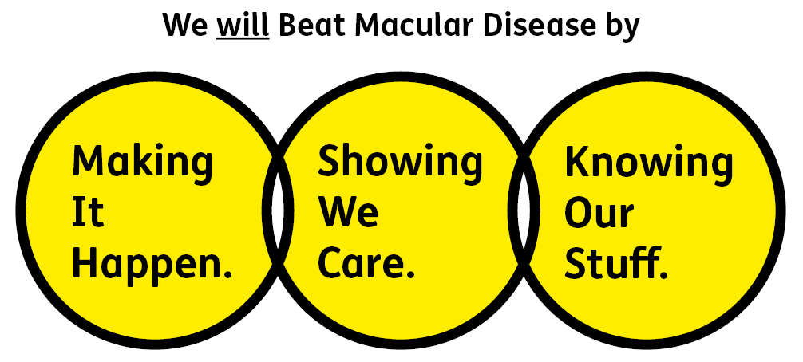

### Showing We Care - we are Supportive and Caring

### Knowing Our Stuff - we have Integrity and we act Honestly

### Making It Happen - we are Ambitious

## Key accountabilities of the role

To support and develop London peer support services.

To recruit, retain and manage volunteers in the London area (and occasionally support development in other England regions).

To develop and maintain relationships with relevant services in the London area, working in partnership for the benefit of people with macular disease.

**Groups and Events:**

* Revitalise existing groups and develop a new network of Macular Society peer support groups in London.
* Develop and facilitate patient information events in London and support England-wide initiatives when required.
* Evaluate the progress and success of Macular Society regional services in London.

**Volunteers**

* Build a network of volunteers for all Macular Society volunteer-delivered services in London (and occasionally in other regions of England).
* Identify and advertise local volunteering opportunities working with other Regional Managers as well as various organisations working with visually impaired people.
* Develop and facilitate training and networking sessions and events for volunteers in London and support development and delivery of other England events if necessary.
* Develop relationships with new and existing volunteers.
* Assist with the roll out of new volunteer roles in England.
* Deal with incoming requests from volunteers for advice, support, information and materials.

**General**

* Support the development and implementation of the Macular Society peer support review and volunteer strategy.
* Record and assist the development and implementation of monitoring/evaluation systems for London regional services.
* Represent the Macular Society at virtual and face to face local, regional and national events to promote all volunteer roles and services.
* Manage the budget as allocated.
* Create resources, publicity materials and regional newsletters for volunteers and service users.

**External**

* Develop relationships with statutory and voluntary sector organisations around and within London, in particular eye clinic professionals.
* Liaise and work with eye clinic professionals to run Patient Information Events.
* Liaise with other societies and volunteer groups to avoid duplication and maximise support to groups, volunteers and the local macular community in London.

All employees will be expected to comply with the Macular Society terms and conditions, rules, policies, procedures, codes of conduct, quality standards, authorisation processes, risk management policies etc. and relevant external regulations.

## Competencies

1. Supports and manages their team and colleagues

2. Works well with others across the Macular Society

3. Is committed to quality and service

4. Understands how the Macular Society operates and follows agreed procedures

5. Delivers their objectives and core activities as required

6. Takes responsibility for their own performance and development

## Person specification

Showing We Care

* Excellent team working and collaborative working skills and the ability to develop effective relationships at all levels.
* An understanding of working with people affected by sight loss.
* An ability to work with and build relationships with people from different backgrounds.
* Excellent interpersonal skills and ability to represent the society and build effective partnerships.
* A team player, with a flexible approach willing to work with and support colleagues across the organisation.
* Commitment to high standards in all areas of work, to provide the best support for those that need us.

Knowing Our Stuff

* Proven experience of working with volunteers.
* Strong organisational and administrative skills and excellent attention to detail
* Monitoring and evaluation systems
* Experience of working in partnership with other organisations.
* Awareness of issues of working for UK wide organisations.
* Good understanding of virtual systems (such as Zoom and conference calling) and technology, including social media platforms.
* Strong IT skills including Word, Excel, PowerPoint, Outlook and experience of working with databases.

Making It Happen

* Be self-motivated, with the ability to work independently and as part of a team
* Ability to multitask and prioritise multiple projects and work streams.
* Experience of facilitating meetings at all levels.
* Excellent written communication skills
* A proactive approach to work and development, with the ability to successfully deliver your objectives.
* Have an understanding of, or proven experience, of successful remote working methods.
* Strong IT skills including Word, Excel, PowerPoint, Outlook.

Desirable:

* Experience of voluntary sector provision for people with sight loss and knowledge of low vision and rehabilitation services in England and in particular the London area.
* Understanding of the issues faced by people who are affected with sight loss, in particular older people.
* Previous experience of working for a charity
* Project management skills.
* Network of VI organisations across England.

Eligibility to work in the UK:

Proof of identity and eligibility to work in the UK.

## Volunteering:

From time to time you may be asked to support / volunteer your time (TOIL available) at Macular Society events that take place outside of normal working hours.

## Safeguarding:

The Macular Society is committed to safeguarding and promoting the welfare of all children, young people and vulnerable adults with whom we work. We expect all of our employees and volunteers to demonstrate this commitment.

The post holder is required to carry out other such duties as may  
reasonably be required, commensurate with the grade of this post. All  
employees are expected to excel in being supporter centric,   
demonstrate advocacy for the Macular Society at all times and be a fundraiser.

This job profile is accurate as at the date shown below. In consultation  
with the post holder it is liable to variation by management to reflect  
or anticipate changes in or to the role.

**Annual leave: 26 days plus bank holidays (pro rata for part time)**

**Based: Andover (home based during the COVID-19 crisis).**

**Contract Type: Permanent**

**DATE OF EVALUATION: August 2023**