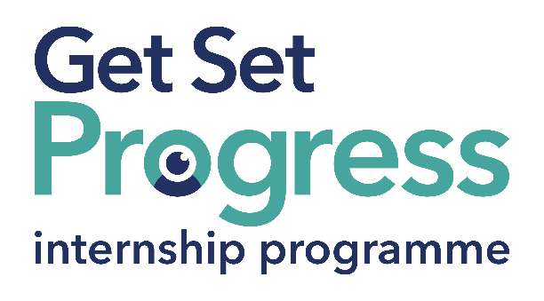

# Junior Fundraising Copywriter

## Join us at Macular Society

Thomas Pocklington Trust (TPT) and RNIB are collaborating with charities in the sight loss sector to create new opportunities for blind and partially sighted people to find employment through the Get Set Progress Internship programme. **Macular Society** is delighted to be offering an internship as part of the Get Set Progress scheme.

Macular disease is the biggest cause of sight loss in the UK, with around 300 people diagnosed every day. The Macular Society is the only charity determined to beat the fear and isolation of macular disease with world class research, and the best advice and support.

To support people affected by macular disease now, the Macular Society provides a range of support, information and services. Our research programme is focused on finding new treatments and a cure to Beat Macular Disease forever.

## Our Values

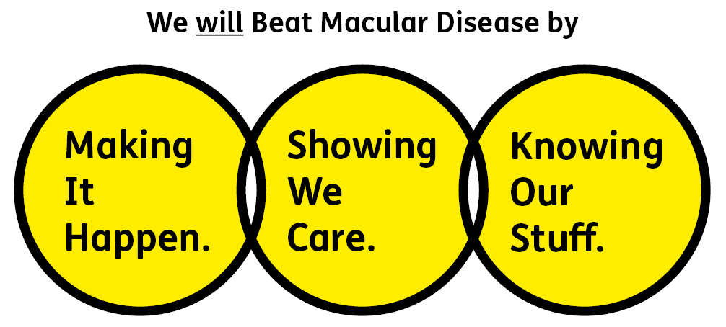

Image above shows three interconnecting circles with our values:

• Showing We Care - we are Supportive and Caring

• Knowing Our Stuff - we have Integrity and we act Honestly

• Making It Happen - we are Ambitious

## What are the benefits of a Get Set Progress internship for me?

As part of your 9-month internship, you will gain the following:

* Obtain valuable work experience within the charity sector
* Training opportunities
* A personal mentor offering support, advice and guidance throughout your internship
* Help deliver positive changes for people with sight loss

As part of the GSP Internship programme, you will also be enrolled on the TPT Employment Programme, where you will gain employment support, guidance and advice from the TPT Employment Team, some of the obtainable skills are:

* CV writing
* Job searching
* Cover letter and speculative letter writing
* Application form writing
* Interview techniques

Job description

Role: Junior Fundraising Copywriter

Department: Engagement Team

Reporting to: Fundraising

Location: Andover or home based, ideally with minimum 2 days office based

Salary: £21,500 per annum (pro rata)

Contract type: Fixed Term 9 months, full time 37.5 hours per week

## Job Specification Information

**Job purpose: Overview of the role:**The Junior Fundraising Copywriter will support our existing content team, creating and helping to create excellent, engaging written content for many areas of the Macular Society including our fundraising appeals, our publications, our emails and our website. This role will cover various subjects – from stories of people affected by macular disease, to fundraising letters, to information about macular disease and how we are working to beat it. The Junior Fundraising Copywriter will need to learn and develop an understanding of our different audiences and the style of writing that is appropriate for them together with how to make content appropriate for the channel.

**Key areas of responsibility:**• Contribute to creating and developing compelling copy that engages relevant audiences, taking into account the needs and objectives of different teams.

• Contributing content for key campaigns, moments and themes across multiple channels.

• Assisting in writing donor, member, volunteer, and beneficiary-centric pieces, sometimes from complex information, which are appropriate for the audience and channel.

• Telling stories in a way that is authentic and appropriate to the audiences and channel.

• Maintaining and updating key online information resources in conjunction with the Editorial Content Manager.

• Working closely with colleagues across the organisation to understand their copy requirements.

• Proof-reading and editing for colleagues across the organisation as and when required.

• Responding to communications with our donors and members – this will include liaising on the phone with our supporters, responding to emails, social media and producing letters – as required.

All employees are expected to comply with Macular Society terms and conditions, rules, policies, procedures, codes of conduct, quality standards, authorisation processes, risk management policies and relevant external regulations.

**Personal spec - Essential criteria:**• Lived experience of sight loss. This post has a Genuine Occupational Requirement that the successful applicant be a person who is blind or partially sighted, in line with The Equality Act 2010.

Knowing Our Stuff

* Attention to detail with exceptional English and grammar skills
* Excellent, accurate written and verbal communication skills in English
* Demonstrable skills in turning complex information into engaging copy
* Understanding how different styles of copy work in different contexts
* An appreciation of what constitutes good supporter care
* Strong IT skills including Word, Excel, PowerPoint, Outlook

Making It Happen

* Ability to manage internal briefs in terms of accepting briefs, time management and delivery schedules
* Ability to bring fresh angles
* Sound creative judgment and ability to put words in context
* Good organisational skills and ability to work independently under own initiative and cooperatively as part of a fundraising team
* Able to prioritise own workload and meet deadlines
* A can-do attitude and hands on approach

Showing We Care

* Excellent team working and collaborative working skills and the ability to develop effective partnerships
* Commitment to high standards in all areas of work
* Ability to tell stories in an authentic way, allowing our case studies to have their voices heard
* Ability to work flexibly to meet the needs of the team

**Desirable criteria:**

* Experience of writing for different audiences and knowledge on how to adapt copy appropriately
* Knowledge of and empathy with issues relating to sight loss
* Letter writing skills
* Working for a charity
* Understanding of different fundraising areas
* Understanding of digital marketing techniques

## Eligibility to work in the UK:

## Proof of identity and eligibility to work in the UK.

**Volunteering:**

## From time to time you may be asked to support / volunteer your time (TOIL available) at Macular Society events that take place outside of normal working hours.

**Safeguarding:**

## The Macular Society is committed to safeguarding and promoting the welfare of all children, young people and vulnerable adults with whom we work. We expect all of our employees and volunteers to demonstrate this commitment.

## The post holder is required to carry out other such duties as may reasonably be required, commensurate with the grade of this post. All employees are expected to excel in being supporter centric, demonstrate advocacy for the Macular Society at all times and be a fundraiser.

## This job profile is accurate as at the date shown below. In consultation with the post holder it is liable to variation by management to reflect or anticipate changes in or to the role.

## What to do next

To apply, please email your CV with a covering letter to: [recruitment@macularsociety.org](mailto:recruitment@macularsociety.org)

Interviews: Weeks beginning 13 and 20 November 2023

Closing date:

17:00 on 06 November 2023

## **About Macular Society**

## We provide a great working culture at Macular Society. – we do something worthwhile and are proud to work together to Beat Macular Disease – as recognised by our inclusion in The Sunday Times Best Places to Work 2023 list.

## We offer flexible working options, 26 days annual leave, rising to 27 after one years’ service, the ability to buy or sell annual leave, supportive family policies, and 6% pension contribution. To find out more and hear what our teams say about working here please visit: macularsociety.org/careers/benefits/

## We are passionate about treating people fairly and as equals, doing so is instinctive to us. We are committed to specific actions to help achieve our ambition of greater representation of lived experience. We are accredited as Disability Confident Employer.