Job description

Job title: Head of Policy and Influencing
Team: Policy and Influencing
Department: Services
Job location: Andover or Home Based
Reports to: Director of Services

Overall purpose
Macular disease is the biggest cause of sight loss in the UK, with around 300 people diagnosed every day. The Macular Society is the only charity determined to beat the fear and isolation of macular disease with world class research, and the best advice and support.

To support people affected by macular disease now, the Macular Society provides a range of support, information and services. Our research programme is focused on finding new treatments and a cure to Beat Macular Disease forever.

Organisational chart

The organisation chart shows the Head of Policy and Influencing reporting into the Director of Services. Also reporting to the Director of Services are the Head of Mental Health and Wellbeing, Head of Sight Loss Support, Head of Community Networks, Head of Information and Advice, and Services Innovation Manager. Reporting into the Head of Policy and Influencing is ‘team to be developed’. There are no current line reports but we are anticipating building a team in this area shortly and involving the Head of Policy and Influencing in this process.

Our values
We will beat macular disease by…

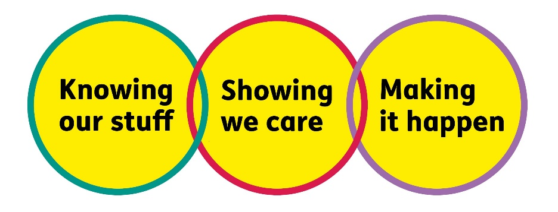

Making It Happen - we are Ambitious

Showing We Care - we are Supportive and Caring
- Knowing Our Stuff - we have Integrity and we act Honestly

About the role

This role provides strategic leadership of the Macular Society’s policy and influencing work, ensuring that the needs and experiences of people living with macular disease shape our policy positions and campaigning activity.
You will be a key member of the Services and organisational Leadership Teams, working collaboratively across the organisation to maximise our impact, influence decision-makers and secure meaningful change that improves outcomes for people with macular disease. You will work alongside regionally based colleagues in Community Networks to leverage influence.
You will lead the development and delivery of a clear policy and influencing strategy, grounded in evidence and lived experience, and ensure that our voice is heard at the highest levels across government, healthcare and the wider sector. This role will be essential to delivering the organisational strategic goal “Making Vision Matter”.
- Develop and deliver a policy and influencing strategy aligned with organisational priorities and user needs
- Act as the organisation’s senior lead on policy and public affairs, advising the Director of Services, CEO and wider leadership team
- Contribute to organisational strategy, culture, planning and performance as part of the leadership team
- Lead the development of robust, evidence-based policy positions, drawing on research, service insight and lived experience
- Monitor, analyse and interpret policy, legislative and healthcare developments relevant to macular disease, communicating developments to key colleagues
- Brief the CEO, Trustees and other senior leaders on policy issues, enabling them to act as effective advocates for Macular Society positions
- Commission and oversee research, consultations and insight gathering to strengthen influencing work
- Ensure the organisation has a strong and credible evidence base to support change
- Build and maintain strong relationships with key stakeholders, including government, NHS, regulators, charities and sector bodies
- Represent the organisation in external forums, coalitions, consultations and events
- Design and lead targeted influencing campaigns to achieve policy and practice change
- Act as a spokesperson where appropriate, working closely with comms and media colleagues
- Ensure that service user voice and lived experience are central to all influencing activity
- Collaborate with communications colleagues to ensure consistent messaging and strong external positioning
- Develop and manage annual business plans, budgets and KPIs for policy and influencing work
- Monitor, evaluate and report on impact and effectiveness of influencing activity
- Ensure compliance with relevant governance, risk and regulatory requirements
- Provide high-quality reporting and insight to senior leaders and trustees
- Lead, manage and develop a high-performing policy and influencing team
- Foster a collaborative, inclusive and high-performance culture

All our team members are expected to comply with Macular Society terms and conditions, rules, policies, procedures, codes of conduct, quality standards, authorisation processes, risk management policies and relevant external regulations.

About you
1. You will be committed to equality, diversity and inclusion in all aspects of our work.
2. Have an open and collaborative approach to work, helping us to achieve our Knowing our stuff value by working with integrity, making informed decisions to be the best we can be to Beat Macular Disease.
3. Be able to act with empathy, we provide a caring, approachable and supportive environment for all – we Show We Care by listening to each other and working together.
4. Be ambitious in your approach to help Make Things Happen, we are progressive yet supportive, and brave in our actions to make the progress that is needed to Beat Macular Disease.
5. Be happy to work in an organisation that puts those we support first, advocate for the Macular Society at all times, and be comfortable that all members of the team are fundraisers.

Specifically for this role you will have:
Knowing Our Stuff
- Strong experience in policy development, public affairs, campaigning or advocacy with evidence of driving change in a healthcare context.
- In-depth understanding of health, social care or disability policy.
- Ability to find and analyse complex evidence, and translate this into clear, compelling policy positions.
- A credible senior professional with good influencing skills and a can do and hands on approach.
- An in-depth understanding of macular disease and its impact on people living with the condition (desirable) or the proven capability to develop such knowledge (essential).
- Proficiency with digital tools, platforms and technologies relevant to public engagement and campaigning.
- Excellent oral and written communication skills, in particular the value of communicating in plain English.
- A commitment to maintaining confidentiality for campaign participants and understanding of data governance frameworks and data protection regulations.

Making It Happen
- Proven ability to develop and deliver influencing strategies that achieve impact.
- Experience of working in partnerships, coalitions or cross-sector collaborations and using these to drive change.
- Flexibility to quickly adapt to new trends and technologies.
- Experience of setting and managing budgets, and an understanding of practicing in a cost-effective way.
- Strong stakeholder engagement and relationship building skills.
- Excellent programme delivery skills and ability to manage diverse and demanding workloads.
- Ability to work independently under own initiative and cooperatively as part of a team
- Ability to multitask and prioritise multiple projects and work streams.
- Strong IT skills including Word, Excel, PowerPoint, Outlook.

Showing We Care
- Excellent leadership skills, including evidence of fostering a challenging and supportive team culture and flexing style to meet the needs of individuals.
- Excellent team working and collaborative working skills and the ability to develop effective partnerships.
- Commitment to high standards in all areas of work.
- Evidence of creating a high performing team environment with positive attitudes, culture and behaviours.
- Team leadership experience in a complex and/or change environment.
- Excellent interpersonal skills, with the ability to engage and collaborate with internal and external stakeholders at all levels.
- Excellent communication and influencing skills at senior level.

Eligibility to work in the UK:
Proof of identity and eligibility to work in the UK.

Volunteering:
From time to time you may be asked to support / volunteer your time (TOIL available) at Macular Society events that take place outside of normal working hours.

Safeguarding:
The Macular Society is committed to safeguarding and promoting the welfare of all children, young people and vulnerable adults with whom we work. We expect all of our employees and volunteers to demonstrate this commitment.
You are required to carry out other such duties as may reasonably be required, relevant to the role.
This job description is accurate as at the date shown below. In consultation with you it is liable to variation by the Macular Society to reflect or anticipate changes in or to the role.

Annual leave: 27 days plus bank holidays (pro rata for part time)
Based: Andover/Hybrid/Remote
Contract Type: Perm/Full Time

Date of evaluation: June 2026

