Job description

General information

Job title: Quality assurance specialist
Team: Digital
Department: Income and Transformation
Job location: Andover/Home/Hybrid
Reports to: Head of Digital
Number of direct reports: 0
Number of volunteer reports: 0
Financial responsibility: Up to £100,000 Expenditure
Matrix reporting lines to: James Price, Head of Data and Insights
Level of disclosure check required and related workforce:
Basic

Overall purpose
Every day, around 300 people are diagnosed with macular disease. It’s the biggest cause of sight loss in the UK. Macular disease is cruel and isolating. It steals your sight, your independence, and your ability to do the things you love. There is only one way to Beat Macular Disease for good.
The Macular Society is working to deliver our ultimate ambition – to Beat Macular Disease for the next generation. We are determined to end the fear and isolation of macular disease with world-class research and the best advice and support.
Our Digital team deliver a first-class digital experience to those looking for support and those looking to support us through our website and our busy email programme. The quality assurance specialist will support our head of digital in ensuring the charity’s digital platforms deliver dependable, accessible, and high-quality experiences for people seeking support and those choosing to support our work. Working across the website, email programme, and other integrated systems, the role is responsible for testing new features and campaigns before they go live, and for identifying issues early to minimise risk to users, income, and data integrity.
Working closely with the Digital, Database, Fundraising teams, the QA specialist supports the delivery of complex digital activity, including work as part of the Digital Data Transformation Project. The role combines structured testing, accessibility checks, first-line digital support, and creation of clear documentation to help maintain trust, usability, and stability across our digital services, while continuously improving quality and reliability over time.
The role will be responsible for testing new technologies that integrate with or interact with digital platforms across the organisation.

Organisational chart

The Head of Digital leads the team structure at the top.
The Quality Assurance Specialist reports to Head of Digital, alongside Email Marketing Manager and Digital Content Manager.

Our values

We will Beat Macular Disease by…
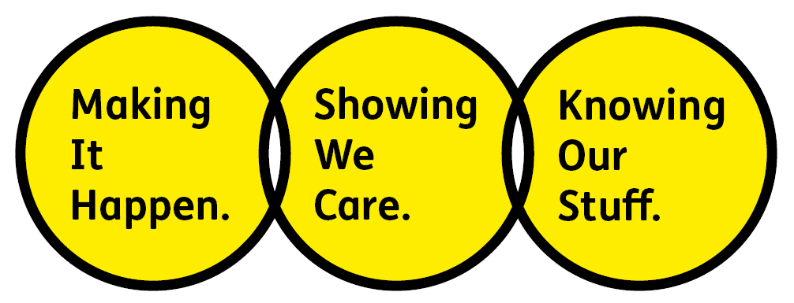

Showing We Care - we are Supportive and Caring.

Knowing Our Stuff - we have Integrity and we act Honestly.

Making It Happen - we are Ambitious.

Key accountabilities of the role
- Plan, execute, and maintain quality assurance testing across all digital platforms, including the website, email platform, CRM, and integrated systems.
- Conduct manual, regression, cross-browser, cross-device, and end-to-end testing of user journeys, campaigns, donation funnels, and new features, with a focus on high-risk areas such as income and supporter data capture.
- Evaluate email campaigns across major mail clients and devices, validating rendering, links, tracking, CTAs, personalisation, and CRM-linked attributes, and investigating resubscription or delivery errors.
- Monitor live environments post-release to identify and respond to issues such as broken journeys, tracking failures, accessibility problems, or data errors.
- Embed accessibility into all testing activity, using automated tools and assistive technologies to identify WCAG issues, resolving minor issues directly and escalating more complex defects where required.
- Validate website, email, and CRM integrations, including data syncing, form submissions, and system APIs, working closely with the database team, particularly during CRM migration UAT phases.
- Conduct performance testing to identify potential issues with load, response times, and system stability across digital platforms and integrations.
- Function as the first point of ownership for digital defects and support issues, managing the digital support inbox, diagnosing problems, and coordinating escalation and resolution with developers or external suppliers.
- Log, track, and manage defects through to resolution, providing clear reproduction steps, coordinating retesting, and ensuring fixes are verified before release.
- Develop and maintain test documentation, scripts, smoke tests, and repeatable QA processes to improve release quality and reduce operational inefficiency.
- Provide regular reporting and insight on defects, testing coverage, post-release incidents, and quality risks, making recommendations to improve digital reliability and reduce future issues.
- Supporting the digital team as required.

All employees are expected to comply with Macular Society terms and conditions, rules, policies, procedures, codes of conduct, quality standards, authorisation processes, risk management policies etc. and relevant external regulations.

Competencies

1. Supports and manages their team and colleagues
2. Works well with others across the Macular Society.
3. Is committed to quality, accuracy, and service excellence
4. Plans and delivers work effectively
5. Understands how the Macular Society operates and follows agreed procedures.
6. Uses judgement and follows agreed processes
7. Delivers their objectives and core activities as required.
8. Takes responsibility for their own performance and development.

Person specification

Essential:
Knowing Our Stuff
- Demonstrable experience of testing digital products including websites, email campaigns, forms, integrations, and multi-step supporter journeys across multiple devices and platforms.
- Sound knowledge of quality assurance best practice, including manual, exploratory, and regression testing, defect management, and release validation.
- Understanding of web technologies and behaviour, including HTML/CSS fundamentals, cross-browser compatibility, and responsive design principles.
- Experience testing email campaigns across major email clients and devices, including rendering, links, tracking, and personalised or data-driven content.
- Understanding of accessibility standards (e.g. WCAG) and experience using accessibility tools within digital testing processes.
- Experience using backend systems such as website CMSs, CRM platforms, and email marketing tools, including testing data flows and integrations.
- Ability to analyse analytics, logs, or reports to identify issues, validate fixes, and inform testing priorities.

Making It Happen
- Plans, prioritises, and delivers testing activity to support timely digital releases, campaigns, and change initiatives, balancing quality, risk, and deadlines.
- Works proactively and in an agile, test-and-learn environment to identify issues early and follow them through to resolution.
- Takes ownership of workload and issues, working independently while keeping colleagues informed of progress, risks, and dependencies.
- Uses sound judgement to focus effort on high-risk areas, such as donation journeys, supporter data, and accessibility issues.
- Adapts quickly to changing priorities and supports urgent releases or incidents while maintaining agreed standards and processes.

Showing We Care
- Puts the needs of sight impaired and sighted audiences at the heart of digital platforms, ensuring accessibility, reliability, and trust.
- Takes responsibility for the quality of digital products and considers the impact of issues on supporters, income, and access to services.
- Works collaboratively across teams, building effective partnerships and communicating issues and risks clearly and respectfully.
- Demonstrates a commitment to high standards, attention to detail, and continuous improvement in all areas of work.
- Supports a positive, inclusive, and professional working environment, showing empathy, patience, and a solution focused approach.

Desirable:
- Previous experience in a digital quality assurance or testing role, ideally within a charity, public sector, or complex stakeholder environment.
- Familiarity with issue-tracking tools such as Trello or similar platforms.
- Experience using technical SEO tools.
- Basic understanding of analytics and tagging tools (GA4, GTM).
- Exposure to test automation frameworks (Selenium, Cypress).
- Knowledge of and empathy with issues relating to sight loss.
- Understanding of fundraising techniques and different fundraising areas.
- Understanding of HTML, CSS and JavaScript.
- Understanding of data protection legislation.

Eligibility to work in the UK:
- Proof of identity and eligibility to work in the UK.

Volunteering:
From time to time, you may be asked to support / volunteer your time (TOIL available) at Macular Society events that take place outside of normal working hours.

Safeguarding:
The Macular Society is committed to safeguarding and promoting the welfare of all children, young people and vulnerable adults with whom we work. We expect all our employees and volunteers to demonstrate this commitment.
The post holder is required to conduct other such duties as may
reasonably be required, commensurate with the grade of this post. All
employees are expected to excel in being supporter centric,
always demonstrate advocacy for the Macular Society and be a fundraiser.
This job profile is accurate as at the date shown below. In consultation
with the post holder it is liable to variation by management to reflect
or anticipate changes in or to the role.

Annual leave: 26 days plus bank holidays (pro rata for part time)
Based: Andover/home/hybrid
Contract Type: Permanent
DATE OF EVALUATION: January 2026

