Trustee Role Description
About us
Macular disease is the biggest cause of sight loss in the UK, with around 300 people diagnosed every day. The Macular Society is the only charity determined to beat the fear and isolation of macular disease with world class research and the best advice and support.
To support people affected by macular disease now, the Macular Society provides a range of support, information and services. Our research programme is focused on finding new treatments and a cure to Beat Macular Disease forever.

Our values
We will beat macular disease by…

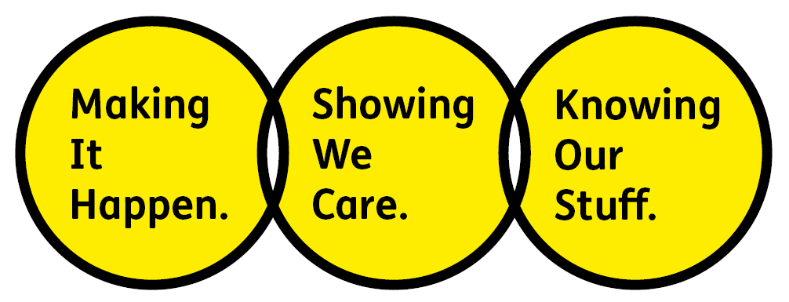

Showing We Care – we are Supportive and Caring

Knowing Our Stuff – we have Integrity and we act Honestly

Making It Happen – we are Ambitious

We are passionate about treating people fairly and as equals; doing so is instinctive to us. We know that to Beat Macular Disease for all we have work to do. That’s why we are keen to hear from people of all backgrounds who have the skills and experience we are looking for. We particularly encourage applications from people from under-represented groups, to help ensure what we do and how we do it is inclusive — for everyone.

Role Purpose
As part of our Board of Trustees, your role will be to contribute to the overall governance and strategic direction of the charity, using your knowledge, skills and experience to ensure the Macular Society achieves its charitable objectives. Alongside the key statutory duties of a charity trustee, the role requires effective leadership, sound judgement, and a commitment to the highest standards of governance and safeguarding.
Main Responsibilities
Knowing Our Stuff
- Comply with the statutory duties of a Trustee under the Charities Act and those of a Director under Company law, maintaining a thorough understanding of legal duties, responsibilities and liabilities of Trusteeship.
- Use own specific skills, knowledge or experience to help the Board reach sound decisions through the scrutiny of Board papers and contribution to Board discussions.
- Work with colleagues to develop the knowledge and capabilities of the Board and senior leadership team.
Showing We Care
- Demonstrate a genuine interest in the vision and purpose of the charity, with a commitment to people living with macular disease.
- Listen to the voices of our beneficiaries, volunteers, staff and other stakeholders of the Macular Society.
- Fully engage with the decisions of the Board and ensure all decisions are implemented.
- Uphold the ethical principles associated with the role of a trustee: selflessness, integrity, objectivity, accountability, openness, honesty and leadership.
Making It Happen
- Apply strategic vision to governance and decision making.
- Work effectively as a member of the Board while simultaneously sharing independent views that can constructively challenge the status quo.
- Ensure that governance arrangements are working in the most effective way to achieve the charity’s objectives and strategic goals.
- Be a proactive ambassador and advocate for the Society, always acting in its best interests.
- Work collaboratively across the organisation and develop effective internal and external partnerships.
We ask the following for all our team members
- You will be committed to equality, diversity and inclusion in all aspects of our work.
- Have an open and collaborative approach to work, helping us to achieve our Knowing Our Stuff value by working with integrity, making informed decisions to be the best we can to Beat Macular Disease.
- Be able to act with empathy; we provide a caring, approachable and supportive environment for all – we Show We Care by listening to each other and working together.
- Be ambitious in your approach to help Make Things Happen; we are progressive yet supportive, and brave in our actions to make the progress that is needed to Beat Macular Disease.
- Be happy to work in an organisation that puts the people we support first, be able to advocate for the Macular Society at all times and be comfortable that all members of the team are ‘fundraisers’.

Person specification
Essential
- A thorough understanding of, and commitment to comply with, the legal duties, responsibilities and liabilities of a charity Trustee under the Charities Act and a Director under Company law.
- A commitment to, and genuine interest in, our mission to Beat Macular Disease, and the ability to act as an ambassador and advocate for the Society.
- The ability to apply strategic vision to governance and decision making, bringing specific knowledge or experience to help the Board reach sound decisions.
- A commitment to the safeguarding of adults at risk, including an understanding of safeguarding responsibilities at Board level, and a commitment to ensure robust safeguarding policies and procedures are in place and regularly reviewed.
- Senior leadership or clinical experience within the health or charity sectors.
- An appreciation of the nature of risk management at Board level, including data security and information governance.
- A willingness to devote the time to scrutinise Board papers, contribute to discussions at meetings, and sit on appraisal, recruitment and other panels or working groups as appropriate.
- A willingness to support the operational management of the charity through collaboration with the staff team.
- Excellent collaborative working skills and the ability to develop effective relationships, both internally and externally, to benefit the Society.
- An ability to work effectively as a member of a team while contributing your own viewpoint.
- A commitment to the following ethical principles which are pivotal for the role of a trustee: selflessness, integrity, objectivity, accountability, openness, honesty and leadership.

Desirable
- Experience of risk management, governance, and legal matters within the health or charity sector.
- An experienced fundraiser within the charity sector.
- Experience in human resources or employment law.
- Experience of safeguarding policies and procedures in relation to vulnerable adults.
- Lived experience of macular disease.
- Experience working as an eye care professional in the area of macular disease, low vision management and service provision.
- An understanding of charity finance and the funding landscape.
Tenure
Trustees are initially appointed for a term of three years. This may be extended for a further three years, up to a maximum tenure of six years.
Date of evaluation: April 2026

