Job description

General Information

Job Title: Regional Manager– Northern Ireland (NI) 22.5hrs

Job Location: Home based. Covering Belfast, South Eastern and Northern Health & Social Care (HSC) Trust.

Reports to: Senior Regional Manager NI

Number of Direct Reports: None

Financial Responsibility: Regional Budget

Level of Disclosure Check Required: Enhanced

Overall Purpose

Every day, around 300 people are diagnosed with macular disease. It’s the biggest cause of sight loss in the UK. Macular disease is cruel and isolating. It steals your sight, your independence, and your ability to do the things you love. There is only one way to Beat Macular Disease for good.

The Macular Society is working to deliver our ultimate ambition – to Beat Macular Disease for the next generation. We are determined to end the fear and isolation of macular disease with world-class research and the best advice and support.

Our services are delivered by a combination of paid staff and dedicated volunteers, providing support, sometimes one to one and sometimes in group settings. Working closely with the Senior Regional Manager, the post holder will recruit, train, develop and support local Macular Society support groups and volunteers across all 3 HSC trusts and occasionally across the whole of NI.

Responsibilities:

Below is a description of the reporting line for this role (Regional Manager NI, reports into the Senior Regional Manager NI, who in turn reports into the Head of Regions, who themselves reports into the Director of Services).

Director of Services
↓
Head of Regions
↓
Senior Regional Manager NI
↓
Regional Manager NI

Our Values
We will beat macular disease by…
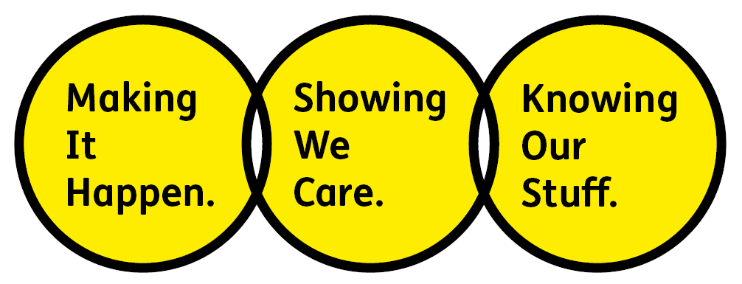

Making It Happen - we are Ambitious

Showing We Care - we are Supportive and Caring

Knowing Our Stuff - we have Integrity and we act Honestly

Job summary
To support and develop peer support services.

To recruit, retain and manage volunteers in the Belfast, South Eastern, and Northern HSC Trust (and occasionally support development in the Western and Southern HSC Trusts).

To develop and maintain relationships with relevant services in the 3 HSC trusts, working in partnership for the benefit of people with macular disease.

Key Accountabilities of the Role

Groups and Events:

- Revitalise existing groups and develop a new network of Macular Society peer support groups in the Belfast, South Eastern, and Northern HSC Trust.
- Develop and facilitate patient information events in the above 3 HSC trusts and support NI-wide initiatives when required.
- Evaluate the progress and success of Macular Society regional services in the Belfast, South Eastern, and Northern HSC Trust.
Volunteers
- Build a network of volunteers for all Macular Society volunteer-delivered services in the Belfast, South Eastern, and Northern HSC Trust (and occasionally in other regions of NI).
- Identify and advertise local volunteering opportunities working with other Regional Managers as well as various organisations working with visually impaired people.
- Develop and facilitate training and networking sessions and events for volunteers in the Belfast, South Eastern, and Northern HSC Trust and support development and delivery of other NI events if necessary.
- Develop relationships with new and existing volunteers.
- Assist with the roll out of new volunteer roles in the Belfast, South Eastern, and Northern HSC Trust.
- Deal with incoming requests from volunteers for advice, support, information and materials.

General
- Record and assist the development and implementation of monitoring/evaluation systems for Belfast, South Eastern, and Northern HSC Trust regional services.
- Represent the Macular Society at virtual and face to face local, regional and national events to promote all volunteer roles and services.
- Manage the budget as allocated.
- Create resources, publicity materials and regional newsletters for volunteers and service users.

External
- Develop relationships with statutory and voluntary sector organisations within Belfast, South Eastern, and Northern HSC Trust, in particular eye clinic professionals.
- Liaise and work with eye clinic professionals to run an annual Patient Information Event in the Belfast HSC.
- Liaise with other societies and volunteer groups to avoid duplication and maximise support to groups, volunteers and the local macular community in Belfast, South Eastern, and Northern HSC Trust.

All employees will be expected to comply with the Macular Society terms and conditions, rules, policies, procedures, codes of conduct, quality standards, authorisation processes, risk management policies etc. and relevant external regulations.

Competencies
To excel in this role, you should:
- Be self-motivated, with the ability to work independently and as part of a team
- Have an understanding of working remotely
- Support your team and colleagues, as appropriate
- Be proficient in working with Microsoft office and database systems.
- Work well with people across the organisation
- Be committed to quality and service
- Understand the Macular Society’s operations and processes
- Deliver your objectives and core activities, as required
- Take responsibility for your performance and development

Person Specification
- An understanding of working with people affected by sight loss.
- An ability to work with and build relationships with people from different backgrounds.
- Awareness of issues of working for UK wide organisations.
- Excellent interpersonal skills and ability to represent organisations.
- IT literate, with strong organisational and administrative skills and excellent attention to detail
- Good understanding of virtual systems (such as Zoom and conference calling) and technology, including social media platforms.
- Ability to work independently, and proactively under own initiative.
- Excellent written communication skills
- The ability to develop and maintain relationships at all levels with excellent interpersonal skills
- A team player, with flexible approach willing to work with and support colleagues across the organisation

Desirable skills/experience:

- Experience of voluntary sector provision for people with sight loss and knowledge of low vision and rehabilitation services in NI and in particular the Belfast, South Eastern, and Northern HSC Trust.
- Understanding of the issues faced by people who are affected with sight loss, in particular older people.

Previous relevant experience and knowledge
- A successful track record working with volunteers.
- Experience of facilitating meetings at all levels.
- Experience of working in partnership with other organisations.
- Microsoft Office and databases
- Monitoring and evaluation systems

Desirable:
- Previous experience of working for a charity
- Project management skills.

Eligibility to work in the UK:
Proof of identity and eligibility to work in the UK.

Volunteering:
From time to time you may be asked to support / volunteer your time (TOIL available) at Macular Society events that take place outside of normal working hours.

Safeguarding:
The Macular Society is committed to safeguarding and promoting the welfare of all children, young people and vulnerable adults with whom we work. We expect all of our employees and volunteers to demonstrate this commitment.

The post holder is required to carry out other such duties as may
reasonably be required, commensurate with the grade of this post. All
employees will be expected to excel in being supporter centric,
demonstrate advocacy for the Macular Society at all times and be a fundraiser.

This role requires extensive travel across Belfast, South Eastern, and Northern HSC Trust (and occasionally to our Head Office in Andover, Hampshire, England).

Good broadband connection is essential for this role.

This job profile is accurate as at the date shown below. In consultation with the post holder it is liable to variation by management to reflector anticipate changes in or to the role.

Annual leave: 26 days plus bank holidays (pro-rata).
Based: Home based in NI (Belfast, South Eastern, and Northern HSC Trust preferred).
Contract Type: permanent

DATE OF EVALUATION: March 2023

