Volunteer Voice
Summer 2026

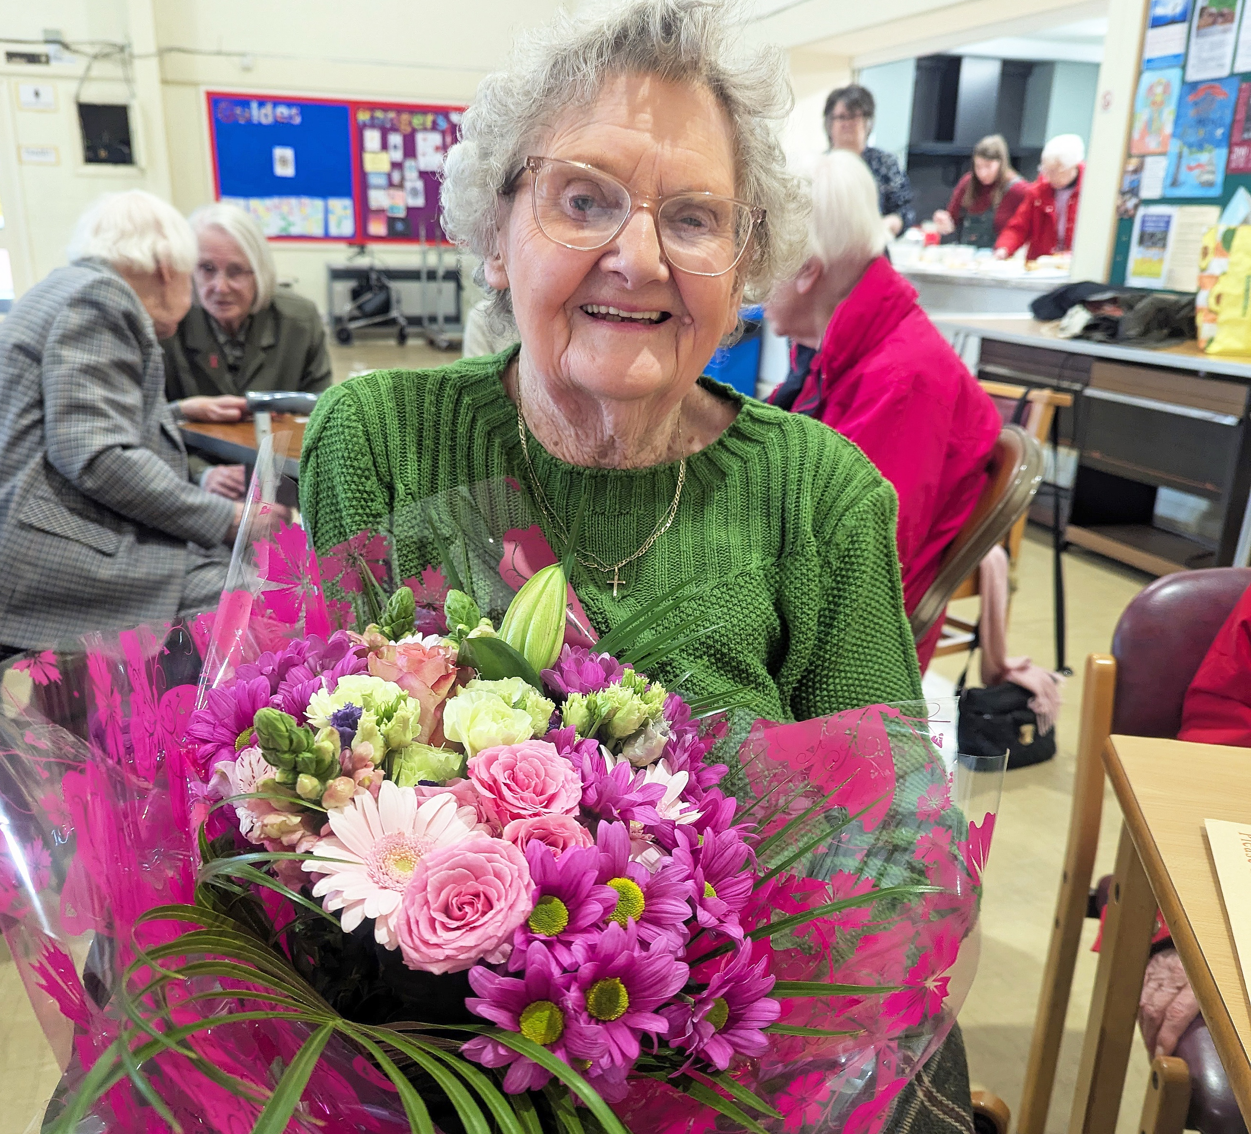

Inside this issue

- How you’re making a big difference
- Exciting new roles and opportunities
- Thank you for everything you do

Pass me on!
Please read and share with other volunteers.

Contents

Page 2 Volunteer stats
Page 3 Welcome
Page 4 Become a community ambassador
Page 5 Back to its best
Page 6 Here for you
Page 7 “Helping people gives you a buzz”
Page 8 Thank you, Barbara!
Page 10 ‘I’m learning how resilient people can be’
Page 12 Gadget gurus

Your key contacts

All services and support-related enquiries:
Helpline 0300 3030 111

Volunteer and group support team:
01264 560 259
groupsupport@macularsociety.org volunteersupport@macularsociety.org

Befriending support:
Befriending 01264 326 622

Information about fundraising and membership:
Supporter care 01264 350 551

Facts and figures about our volunteers

(stats correct as of April 2026)

- We have 891 volunteers performing 1,060 roles.

- We have the most volunteers in the south of England.

- Our volunteers contribute over 55,000 hours a year (if they only volunteer for one hour per week, per role).

- If one person worked 24/7 without breaks, it would take them more than five years to match our volunteers’ annual contribution!

- Our Macular Society volunteers could fill 11 double-decker buses!

Welcome

Welcome to your 2026 issue of Volunteer Voice

Over the past few months, there have been changes to the Macular Society regional staff, and we are so grateful to you for helping our macular community to navigate any challenges. I’ve really enjoyed meeting many of you during our Volunteer Connect calls (page 6) and look forward to more chats.

We are committed to supporting you in everything you do, and we want to work closely with you to develop new roles and recruit more volunteers from around the UK. If there are people in your networks who you think could help to beat the fear and isolation of macular disease, we’d love to hear from them!

Volunteer Voice celebrates your dedication and passion, and inside this issue, I’ve been bowled over by the personal stories shared. From Barbara’s decades of dedication as a group leader (page 8) to Peter’s deserved award (page 7).

I hope you feel as inspired as I do when you read them.

We’re also sharing some exciting opportunities (page 6) as well as one of our newer roles, the community ambassador (page 4).

Thank you for the difference you make every day to people living with macular disease. I hope you enjoy your magazine and have a wonderful summer.

Ed Holloway
Chief executive, Macular Society

Become a community ambassador

Would you like to represent the Macular Society in your local area? We are incredibly grateful to our volunteer speakers, who play a vital role in raising awareness and connecting people to support services across the UK. Working alongside our existing volunteers, we are now introducing a new, complementary role – community ambassadors. We hope to reach thousands more people living with macular disease and sight loss, and provide life-changing support. This is a flexible, micro-volunteering role, where you can give as much or as little time as you can.

What will I be doing?

- Researching community groups, schools and businesses in your area and building strong connections, through speaking and sharing information.

- You will be a consistent and supportive point of contact to signpost people to the relevant teams within the Macular Society so they can access the support or information they need.

- Working alongside the community engagement managers, updating them on your contacts and talks. Community engagement managers will be there to provide you with support, guidance, and advice.

Libby Cameron is based in Edinburgh and last year became one of our Macular Society community ambassadors. Her priorities so far have been to raise awareness of age-related macular degeneration (AMD) within her community and the support groups.

To find out more about this opportunity, email volunteersupport@macularsociety.org
Back to its best

The Tynedale Macular Society Support Group was set up in 2014 and quickly became a valued community initiative, bringing people together across Northumberland. However, during the pandemic, the group leader Isobel moved away, and it was sadly forced to close.

Thankfully, in a positive and inspiring turn, the group has recently been revived after a five-year hiatus. Under the guidance of its original leader, Isobel, the Tynedale group is once again flourishing – welcoming new members every month and rebuilding its presence in the community.

Group leader Isobel said: “I really missed the group when it closed. The group is a lifeline for me and the members.”

After relocating to a new venue, the Tynedale group has attracted lots of new members and has been enjoying bringing in a variety of guest speakers, such as RNIB and Vision Northumberland to share information and tips.

In June, the group is taking part in a day trip to the Vision Northumberland headquarters and members are really looking forward to it!

Here for you

Our first Volunteer Forum meeting took place in April, allowing volunteers from across the UK to share insight, shape improvements, and help develop the future of volunteering at the Macular Society. The forum is a place where volunteer voices can be heard and feedback and ideas can be shared. Look out for updates on the volunteer forum in your quarterly email newsletter.

Build your IT skills

Would you like to feel more confident about using technology? Why not join our new IT for All volunteers group?

Volunteers meet bi-monthly online and the sessions provide a friendly and supportive space to talk about gadgets, accessible technology and practical ways IT skills can make everyday tasks a little easier.

To find out more about the group or attend one of our upcoming sessions, please call volunteer and group support on 01264 560 259 or go to macularsociety.org/support-form and write ‘IT for all’ as the name of the group.

Join our next Volunteer Connect call

Ask your volunteering questions and share your ideas with Macular Society chief executive officer Ed Holloway and director of services Jessica Kirby on our next Volunteer Connect Zoom call.

Dates for your diary
1pm 30 June
1pm 22 July

To sign up, contact volunteersupport@macularsociety.org

Save the date!
Join our Macular Society Conference on Saturday 12 September. Find out more at macularsociety.org/conference

‘Helping people gives you a buzz’

Peter was diagnosed with Stargardt disease at the age of 10, but it wasn’t until a chance encounter in 2022 that he finally met someone else with the condition.

After chatting with Jeanie by the seafront near his home in Teignbridge, he became involved with the Teignbridge Macular Society Support Group. After attending, Peter soon ended up running the group, which has since gone from strength to strength.

“I’m able to share everything I know about macular disease, and ways of coping based on my experiences. When you know you can help people, it gives you a buzz. Some of the best meetings are just when we chat away, people feel more confident to open up about their experience and they love it,” Peter shared.

Supporting others

Peter’s passion for supporting local people with sight loss was recognised when he received the Volunteer of the Year award at the Stars of Teignmouth Awards 2025. He had been nominated for ‘transforming the lives of blind and partially sighted adults across Teignmouth and the surrounding areas by founding and leading the local Macular Society Group’.

Pauleen, who has attended the Teignmouth group, said: “Peter has made a huge difference in my life... Peter is extremely helpful, patient, committed and knowledgeable and I am full of admiration for him.”

Thank you Peter for making a real difference in your community and congratulations on your award!

Thank you, Barbara!

For 24 years, Barbara has been the driving force behind the Macular Society Chesterfield Support Group, and to mark this outstanding achievement, group members and people across the local area came together to pay tribute to her incredible volunteering.

Barbara’s dedication, warmth, and commitment have shaped the group into what it is today: a place of connection, support, and belonging.

During the event, members shared how Barbara always put incredible effort into organising the programme of activities, finding engaging speakers, and ensuring that every meeting was worthwhile.

One member described her as having “amazing fortitude”. Even while facing her own health challenges, Barbara remained welcoming, positive, and determined – always putting the group first and making sure everyone felt included.

A sense of community

Others reflected on what the group itself has meant to them, describing it as a place to learn, to connect with others, and to feel safe. That sense of community doesn’t just happen – it’s built over time by someone who cares deeply, and Barbara has done exactly that.

There were also so many cherished memories mentioned, including summer outings, Christmas meals, and all the moments in between that brought people together and created lasting friendships.

It was wonderful to see Barbara recognised with a Platinum Volunteer Award, along with flowers and a beautiful rose from the group – small tokens compared to the enormous impact she has had.

The overwhelming feeling in the room was one of gratitude. Gratitude for her leadership, her kindness, her resilience, and her unwavering commitment over more than two decades.

Barbara, thank you. For everything you’ve done, for the lives you’ve touched, and for the community you’ve built. Your legacy will continue in this group for many years to come.

Eileen first met Barbara in 2020 when she was introduced to the group. However, soon after lockdown began, she found herself spending a lot of time alone. Barbara took it upon herself to ring group members for regular chats and support. “I really enjoyed her phone calls... I’m so grateful for Barbara ringing up and keeping me in touch with things.”

Barbara would chat about day-to-day life and pass on information. She even introduced Eileen to a meal delivery service that could bring her home-cooked lunches.

“What I want to say now, and I’m sure it’s on behalf of all of us, is we’re going to miss you, Barbara. Thank you,” Eileen added.

Do you want to celebrate someone in your community who goes the extra mile?

Email editor@macularsociety.org to tell us more.

‘I’m learning how resilient people can be’

Norma was diagnosed with macular disease nearly 10 years ago and when her second eye began experiencing problems, she felt distraught, admitting “I didn’t really know what to do with myself”.

She reached out to the Macular Society, initially to receive practical support to adapt to daily life and ended up chatting to a befriender named Chris. The two talked on the phone about everything from technology and reading music to grief and loss.

Chris recommended that Norma also train to be a befriender, and after a year of conversations with Chris she felt ready to give back. “Chris was so wonderful and consistent. I was a therapist for many years in the NHS and in private practice and I didn’t need another therapy. I needed somebody who could help me through the practicalities and to acknowledge my grief,” Norma explained.

Norma has now been a Macular Society befriender for over eight years and has talked to a wide variety of people, each with different interests and experiences of sight loss.

“The first person I got paired with was an older woman who had dry macular and hearing problems,” Norma shared. “She spoke Italian, as she had been a translator, and she loved music and poetry. It was a match made in heaven! We both got such a lot out of it.”

Throughout her befriending and training Norma has become confident in signposting people to different services in the Macular Society, such as counselling, and admitted to feeling “very well supported” by the befriending team if she came across any problems.

Giving back

Norma described her befriending role as a “very satisfying way to give back”.

“I feel I’m talking with people who are further on than me. I haven’t lost my vision, but my vision is changing. I’m learning about how things develop, how resilient people can be and the services and technical devices out there that can help you,” Norma shared.

When asked what advice she had for new befrienders, Norma added: “If you have a capacity to make relationships, to talk, to bear peoples’ distress, do it. Because you will be talking to people who are shocked and distressed, and also lonely.”

Befriending stats
We have 159 befrienders supporting 234 befriendees.

In the last 12 months there have been:

125 new referrals

116 new matches

23 new volunteers

Over 100,000 minutes of calls made

Gadget gurus

Jan Stuart recently joined our Connect by Tech service. We caught up with him to find out more about his new role.

What inspired you to volunteer with Connect
by Tech?
“I contacted the Society to suggest it would be useful if there was a technical group, because I’m quite technical, and it could be online rather than local. They introduced me to Connect by Tech.”

What does a typical enquiry look like?
“A lot of people have a computer but they’re finding that macular degeneration has made it difficult to do things. Even if they’re reasonably technical, they may not know that there is accessibility assistance built into computers and phones.”

“I can often do it on the phone and, if they’re sitting in front of their computer, I can talk them through it step by step. You can tell people about certain settings or programmes to download and they suddenly say: ‘Oh I didn’t know I could do that.’”

What difference do you think Connect by Tech can make?
“I think it makes a lot of difference, because people with sight loss can get frustrated that they can’t do what they used to do. There’s such a wealth of tech nowadays which can help. If you’ve got sight loss, switching to using voice commands is really effective.”

To find out more, go to macularsociety.org/tech

ENDS

