Job description

Job title: Senior Community Engagement Manager Northern Ireland (Maternity Cover)
Team: Community Engagement Team
Department: Services
Job Location: Home-based
Reports to: Head of Community Networks
Direct reports: 5
Volunteer reports: 0
Salary: £39,000 - £41,000 per annum
Level of disclosure check required and related workforce: Basic

Overall purpose
Macular disease is the biggest cause of sight loss in the UK, with around 300 people diagnosed every day. The Macular Society is the only charity determined to beat the fear and isolation of macular disease with world class research, and the best advice and support.

To support people affected by macular disease now, the Macular Society provides a range of support, information, and services. Our research programme is focused on finding new treatments and a cure to Beat Macular Disease forever.

The Community Engagement team is responsible for supporting local community groups, strengthening volunteer networks, and fostering partnerships with the wider community.
The team is designed to strengthen relationships with volunteers, local organisations and stakeholders while driving innovative solutions to support community needs.

Organisational chart

The Director of Services leads the team structure at the top. The Head of Community Networks reports directly to the Director. The Senior Community Engagement Manager reports to the Head and oversees five Community Engagement Managers.

Our values
We will beat macular disease by…

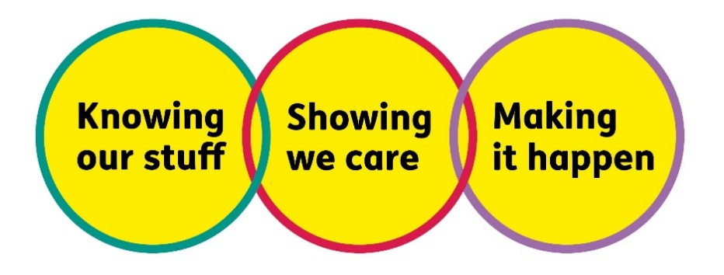

Making It Happen - we are Ambitious

Showing We Care - we are Supportive and Caring
- Knowing Our Stuff - we have Integrity, and we act Honestly

Key accountabilities of the role:
- Provide oversight and strategic direction for peer support in own country, supporting the team to do the same in their nations. Ensuring they have the resources, guidance and structure needed to thrive and remain sustainable.
- Work with the Community Engagement Managers to develop and test new models of community-based support for people living with macular disease
- Support the engagement and development of volunteers through effective coordination, including proposing and implementing new volunteer roles in partnership with the Volunteer and Group Support team.
- Identify, engage, build, and nurture relations with key stakeholders and influencers at a strategic level nationally to ensure that macular disease is a priority
- Facilitate volunteer events, including leading the planning and facilitation of volunteer development day in one's own country, and support the wider team to do this in the other nations.
- Work in partnership with the trusts team to identify funding opportunities for our community engagement work
- Provide macular-specific advice, information and learning to external partners and stakeholders to enhance understanding and influence service delivery.
- Be knowledgeable and up to date on local and universal services to signpost/refer people accordingly.
- Foster strong working relations across internal teams, to ensure a joined-up approach to community engagement and volunteer support.
- Manage the Community Engagement Managers.
- Lead the delivery of engagement activity within the allocated nation, ensuring local needs and insights inform national approaches.
- Gather and share insight from volunteers and communities to inform service development and support strategic decision-making across the organisation.
- Promote equality, diversity, and inclusion in all aspects of engagement, ensuring volunteer-led activity is accessible, welcoming, and reflective of the communities we serve.

Specifically for this role, you will have:
Knowing Our Stuff
- Experience in service delivery and the effective management of budgets.
- A credible and confident senior professional with strong influencing skills and a practical, hands-on approach.
- Experienced and supportive line manager with a development-focused approach.
- Deep insight into the communities and nations in Northern Ireland (NI), with an understanding of how national dynamics shape volunteer experience.
- A proactive approach to staying informed about trends, challenges, and opportunities across the community network, using insight to support strategic decisions.
- A commitment to building your team’s knowledge and sharing learning across the organisation to inform and improve our work.

Making It Happen
- Excellent programme and project delivery skills, with the ability to manage a diverse and demanding workload.
- Able to balance independent decision-making with collaborative teamwork.
- Strong organisational skills, with the ability to prioritise multiple projects and workstreams effectively.
- Proficient in using IT systems and tools, including Microsoft Word, Excel, PowerPoint, and Outlook.
- Leads with clarity and purpose, managing your team and region flexibly and effectively.
- Oversees the delivery of engagement initiatives in NI, such as Volunteer Development Days, community events, and strategic partnerships.
- Encourages innovation and supports your team to test new approaches, adapt to change, and continuously improve.
- Build relationships with NI eye care and health professionals to strengthen local networks and increase referrals to Macular Society support.

Showing We Care
- Strong teamwork and collaborative skills, with the ability to build effective partnerships internally and externally.
- A commitment to high standards, delivering quality and consistency across all areas of work.
- Build meaningful and respectful relationships with volunteers, colleagues, and partners across NI.
- Leads with empathy, integrity, and emotional intelligence, ensuring team members feel supported, valued, and empowered.
- Actively advocates for community voices and ensures volunteer perspectives are embedded in service design and delivery.
- Champions equity and inclusion in all aspects of engagement, leadership, and support.

Eligibility to work in the UK:
Proof of identity and eligibility to work in the UK.

Volunteering:
From time to time, you may be asked to support/volunteer your time (TOIL available) at Macular Society events that take place outside of normal working hours.
Travel:
You will be expected to travel across your designated nation or region, and to attend occasional events at the Andover office.

Safeguarding:
The Macular Society is committed to safeguarding and promoting the welfare of all children, young people, and vulnerable adults with whom we work. We expect all our employees and volunteers to demonstrate this commitment.
You are required to carry out other such duties as may reasonably be required, relevant to the role.
This job description is accurate as of the date shown below. The Macular Society may vary it in consultation with you to reflect or anticipate changes in or to the role.
Annual leave: 26 days plus bank holidays
Based: Andover/Hybrid/Remote
Contract Type: Full time, 9 month fixed-term contract
Date of evaluation: Dec 2025

