Job description

General information

Job title: Advice and Information Operative
Team: Advice and Information Services
Department: Services
Job location: Andover Office
Reports to: Advice and Information Services Manager
Number of direct reports: 0
Number of volunteer reports: 0
Financial responsibility: N/A
Matrix reporting lines to: N/A

Level of disclosure check required and related workforce:
Enhanced

Overall purpose
Every day, around 300 people are diagnosed with macular disease. It’s the biggest cause of sight loss in the UK. Macular disease is cruel and isolating. It steals your sight, your independence, and your ability to do the things you love. There is only one way to Beat Macular Disease for good.
The Macular Society is working to deliver our ultimate ambition – to Beat Macular Disease for the next generation. We are determined to end the fear and isolation of macular disease with world-class research and the best advice and support.

Organisational chart

The Advice & Information Operative reports into the Advice and Information Services Manager, along with two other Advice & Information Operatives and one Advice and Information Operative and Services Administrator.

Our values

We will beat macular disease by…

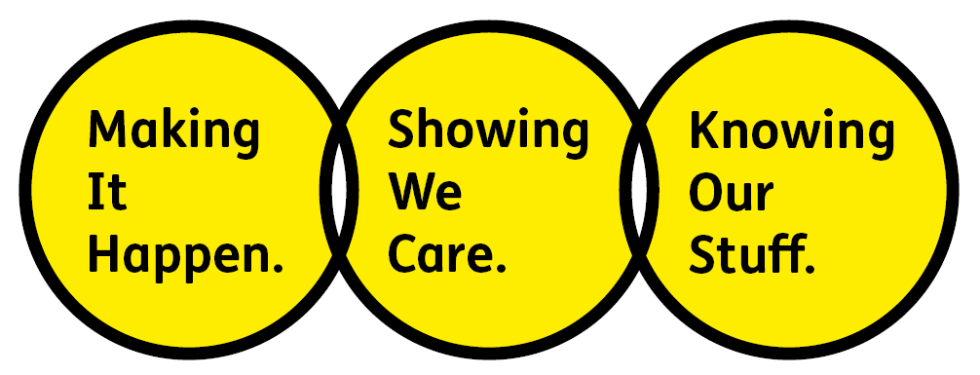

Showing We Care - we are Supportive and Caring

Knowing Our Stuff - we have Integrity and we act Honestly

Making It Happen - we are Ambitious

Key accountabilities of the role
As part of our Advice and Information team, you will be helping to provide clear support, information and advice to over 18,000 people every year that are affected by macular conditions.

- Answering calls, email and social media enquiries from our members, newly diagnosed people and family members looking for support.
- Providing clear, informative, advice and support, as well as signposting people to the right services.
- Monitoring and responding to questions on the Society’s social media sites and on-line forums such as Health Unlocked.
- Contributing to the drafting of new, and reviewing and updating existing patient information, including leaflets, website information and video library.
- Liaising with health care professionals to ensure our patient information is accurate and up to date.
- Contribute flexibly across the work of the Society performing duties commensurate with the role as required.

All employees are expected to comply with Macular Society terms and conditions, rules, policies, procedures, codes of conduct, quality standards, authorisation processes, risk management policies etc. and relevant external regulations.

Competencies

1. Supports and manages their team and colleagues
2. Works well with others across the Macular Society
3. Is committed to quality and service
4. Understands how the Macular Society operates and follows agreed procedures
5. Delivers their objectives and core activities as required
6. Takes responsibility for their own performance and development

Person specification

Essential:

Knowing Our Stuff
- Experience in a busy advice line, call centre or similar customer service role.
- Excellent written and verbal communication skills with ability to absorb complex technical information and relay it to a lay audience
- Strong IT skills including Word, Excel, and Outlook.

Making It Happen
- Good organisation skills and the ability to record information accurately and methodically.
- Ability to work independently under own initiative and cooperatively and flexibly as part of a team
- Ability to multitask and prioritise multiple projects and work streams.

Showing We Care
- Empathic, patient and caring nature
- Calm under pressure and able to manage own emotions
- Excellent active listening skills
- Excellent team working and collaborative working skills and the ability to develop effective partnerships.
- Commitment to high standards in all areas of work.

Desirable:
- Experience in the low vision sector and/or working with older people
- Experience or understanding of sight loss

Eligibility to work in the UK:
Proof of identity and eligibility to work in the UK.

Volunteering:
From time to time you may be asked to support / volunteer your time (TOIL available) at Macular Society events that take place outside of normal working hours.

Safeguarding:
The Macular Society is committed to safeguarding and promoting the welfare of all children, young people and vulnerable adults with whom we work. We expect all of our employees and volunteers to demonstrate this commitment.
The post holder is required to carry out other such duties as may
reasonably be required, commensurate with the grade of this post. All
employees are expected to excel in being supporter centric,
demonstrate advocacy for the Macular Society at all times and be a fundraiser.
This job profile is accurate as at the date shown below. In consultation
with the post holder it is liable to variation by management to reflect
or anticipate changes in or to the role.

Annual leave: 26 days plus bank holidays (pro rata for part time)
Based: Andover
Contract Type: Full time, Permanent

DATE OF EVALUATION: January 2023

