# Job description

## General information

**Job title**: Ecosystem Manager

**Team**: Research

**Department:** Research

**Job location:** Andover with Hybrid Options Available

**Reports to:** Director of Research

**Number of direct reports:** 0

**Number of volunteer reports:** 0

**Level of disclosure check required and related workforce:**

Enhanced

## Overall purpose

Every day, around 300 people are diagnosed with macular disease. It’s the biggest cause of sight loss in the UK. Macular disease is cruel and isolating. It steals your sight, your independence, and your ability to do the things you love. There is only one way to Beat Macular Disease for good.

The Macular Society is working to deliver our ultimate ambition – to Beat Macular Disease for the next generation. We are determined to end the fear and isolation of macular disease with world-class research and the best advice and support.

## Organisational chart

The Macular Society has ambitious plans to grow their research programme in order to move closer to a cure for macular disease. This role will work closely with the Director of Research and the wider Research Team to implement our innovation programme. The Ecosystem Manager will be responsible for conducting research into sight loss technology (diagnostic and patient support) and launch support programmes for innovators. As part of a small team, the role involves a wide range of responsibilities and will include working across the charity with the Fundraising and Services teams.

The Organisation Chart above depicts the research team, which consists of the Director of Research, the new Ecosystem Manager Role, the Research Manager, two Research Officers and a Patient Information officer. The Ecosystem Manager and Research Manager report to the Director of Research the three officer roles report to the Research Manager.

## Our values

We will beat macular disease by…

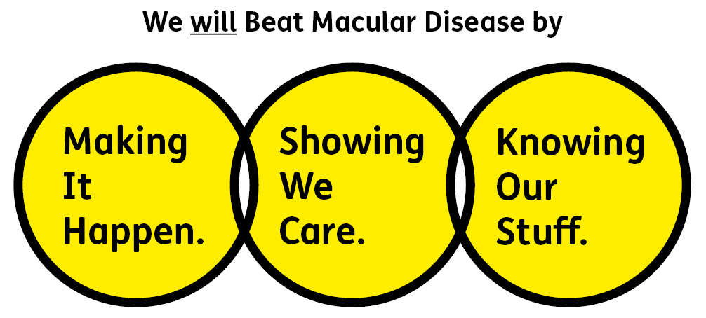

### Showing We Care - we are Supportive and Caring

### Knowing Our Stuff - we have Integrity and we act Honestly

### Making It Happen - we are Ambitious

## Key accountabilities of the role

* Support the research team in the ongoing management of the research programme and commitments to the wider organisation and members of the Macular Society.
* Conduct market research and ecosystem mapping to inform the development of new programmes.
* Engage a range of partners including: startups, corporates, technology developers, biotechs, academics, investors etc.
* Design and implement programmes based on research and a range of evidence.
* Seek independent reliable advice.
* Support the Director of Research in setting up the technology innovation programmes.
* Implement appropriate KPI structures for new programmes.
* Support Skills for Seeing and Connect by Tech with research into the latest tools and solutions.
* Develop an innovation assessment committee to appraise solutions and manage the process of application calls.
* Manage the involvement of patients with technology developers, through development of a proactive approach.
* Actively communicate and promote the research funded by the Macular Society and be a trusted source of information on technology related to macular disease research, diagnosis and treatments.

All employees are expected to comply with Macular Society terms and conditions, rules, policies, procedures, codes of conduct, quality standards, authorisation processes, risk management policies etc. and relevant external regulations.

## Competencies

1. Supports and manages their team and colleagues

2. Works well with others across the Macular Society

3. Is committed to quality and service

4. Understands how the Macular Society operates and follows agreed procedures

5. Delivers their objectives and core activities as required

6. Takes responsibility for their own performance and development

## Person specification

### Essential:

Knowing Our Stuff

* Educated to degree level or demonstrate equivalent working experience in an appropriate scientific or technical field.
* Experience of conducting research through a range of approaches, working within an innovation focused organisation or funder.
* A comprehensive understanding of research, development and innovation.
* An understanding of ecosystem development
* Excellent organisational skills and attention to detail.
* Strong IT skills including Word, Excel, PowerPoint, Outlook.

Making It Happen

* Experience of communicating science and technology to a non-expert audience, or can demonstrate this capability.
* Experience developing partnerships or collaborations with the partners described in Accountabilities.
* Strong stakeholder management skills.
* Proven ability of developing, designing, and implementing programmes
* Ability to work independently under own initiative and cooperatively as part of a team
* Ability to multitask and prioritise multiple projects and work streams.

Showing We Care

* The ability to liaise and build relationships with a variety of people, including Macular Society members and supporters, and the wider eye research, development and innovation ecosystem.
* A team player, with a flexible approach willing to work with and support colleagues across the organisation.
* Commitment to high standards in all areas of work.

**Desirable:**

* Knowledge of and empathy with issues relating to sight loss.
* Experience with market research software.
* An understanding of the startup lifecycle and the associated funding.
* Knowledge of innovation funding and in kind support mechanisms.
* Experience of setting up advisory boards and liaising with researchers and innovators at a senior level.

Eligibility to work in the UK:

Proof of identity and eligibility to work in the UK.

## Volunteering:

From time to time you may be asked to support / volunteer your time (TOIL available) at Macular Society events that take place outside of normal working hours.

## Safeguarding:

The Macular Society is committed to safeguarding and promoting the welfare of all children, young people and vulnerable adults with whom we work. We expect all of our employees and volunteers to demonstrate this commitment.

The post holder is required to carry out other such duties as may  
reasonably be required, commensurate with the grade of this post. All  
employees are expected to excel in being supporter centric,   
demonstrate advocacy for the Macular Society at all times and be a fundraiser.

This job profile is accurate as at the date shown below. In consultation  
with the post holder it is liable to variation by management to reflect  
or anticipate changes in or to the role.

**Annual leave: 26 days plus bank holidays (pro rata for part time)**

**Based: Andover (home based during the COVID-19 crisis).**

**Contract Type: Permanent**

**DATE OF EVALUATION: 21/06/2023**