Job description

Job title: Mid-Value Donor Manager
Team: Trusts & Philanthropy
Department: Fundraising
Job location: Andover or Home Based
Reports to: Head of Trusts & Philanthropy

Overall purpose
Macular disease is the biggest cause of sight loss in the UK, with around 300 people diagnosed every day. The Macular Society is the only charity determined to beat the fear and isolation of macular disease with world class research, and the best advice and support.

To support people affected by macular disease, the Macular Society provides a range of support, information and services. Our research programme is focused on finding new treatments and a cure to Beat Macular Disease within a generation.

Role Overview
We are looking for an enthusiastic and experienced fundraiser to develop and manage our mid-value donor programme, driving significant income growth from supporters giving between £500 and £10,000 per year.

This is an exciting opportunity to build and shape a dedicated mid-value programme within a passionate and ambitious team. Working closely with the Head of Trusts and Philanthropy, you will identify, recruit and develop mid-value donors from cold sources and from amongst our existing supporters and members, creating tailored appeal programmes and stewardship journeys that inspire significant and sustained giving.
You will work in close liaison with the Individual Giving team to ensure donors receive the best possible experience and are placed on the most appropriate supporter journeys. More than just a fundraising role, this is a unique opportunity to make a meaningful impact for people affected by macular disease.

Organisational chart
Head of Individual Giving

The chart above shows the Mid-Value Donor Manager reporting to the Head of Trusts and Philanthropy and shows a dotted line to the Head of Individual Giving who the role will work closely with.

Our values
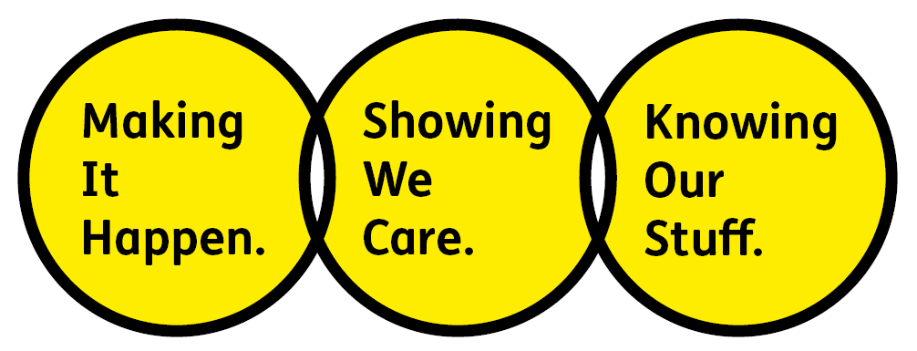
We will beat macular disease by…

Making It Happen - we are Ambitious

Showing We Care - we are Supportive and Caring
- Knowing Our Stuff - we have Integrity and we act Honestly

About the role
Working as part of a passionate and ambitious team you will:
Donor Recruitment & Development
- Develop and implement a strategy for mid-value donor fundraising working closely with relevant teams and our agency partner.
- Identify and recruit mid-value donors from cold sources and from amongst current supporters and members, using data analysis and insight to target those with the capacity and propensity to give at a higher level.
- Develop and implement a compelling mid-value appeal programme that drives significant giving, moving donors through a structured cultivation, reporting and solicitation journey.
- Create and deliver tailored ask strategies, including direct mail appeals, personalised emails and telephone fundraising, to inspire donors to increase their support.
- Identify and qualify donor prospects with the greatest potential for progression into Philanthropy – or from Philanthropy into Mid-Value – ensuring a seamless and structured transition to higher value giving.
- Deliver against agreed income targets and budgets, with flexibility to adapt as organisational priorities and circumstances evolve.
Stewardship & Donor Care
- Deliver prompt and personalised thank you communications by letter and email, ensuring every donor feels valued and appreciated.
- Make personal thank you and update calls to mid-value donors, building relationships and deepening their connection with the charity’s work.
- Deliver exemplary and creative stewardship that responds to individual donor needs and inspires continued and increased support.
- Manage donor enquiries and requests, proactively ensuring timely and appropriate responses across mail, email, telephone and face-to-face channels.

Events
- Plan and deliver two flagship donor events per year: an Impact Research Event and a Christmas event to celebrate and thank supporters.
- Develop and manage the logistics, invitations, briefings and follow-up for each event, ensuring a first-class donor experience.
Cross-Team Working & Donor Journeys
- Work in close liaison with the Individual Giving team to identify donors ready to be upgraded and ensure seamless transition between giving levels, transferring donors back to the Individual Giving team when appropriate.
- Collaborate with the Individual Giving team to ensure mid-value donors are on the most appropriate supporter journeys and are not receiving conflicting or duplicative communications.
- Work with external agencies where required to support the agreed appeal strategy, creative production, data processing and fulfilment.
Data, Insight & Reporting
- Manage the mid-value donor pipeline using the CRM (currently CARE, but from February 2027 Dynamics 365), accurately recording communications, coding income, logging actions and tracking donor progression.
- Feedback on mid-value programme requirements to inform the transition to new CRM (Dynamics 365).
- Monitor and report on programme performance against targets, providing regular updates to the Head of Trusts and Philanthropy and Head of Individual Giving.
General
- Keep up to date with best practice in fundraising and comply with relevant legislation including GDPR and the Code of Fundraising Practice.
- Support the rest of the fundraising team when required with specific projects and events.
- Any other duties as may reasonably be required, relevant to the role.
All our team members are expected to comply with Macular Society terms and conditions, rules, policies, procedures, codes of conduct, quality standards, authorisation processes, risk management policies and relevant external regulations.
About you
- You will be committed to equality, diversity and inclusion in all aspects of our work.
- Have an open and collaborative approach to work. Helping us to achieve our Knowing Our Stuff value by working with integrity and making informed decisions to support us to be the best we can be to beat macular disease.
- Be able to act with empathy, providing a caring, approachable and supportive environment for all – we Show We Care by listening to each other and working together.
- Be ambitious in your approach to help Make Things Happen, we are progressive yet supportive, and brave in our actions to make the progress that is needed to beat macular disease.
- Be happy to work in an organisation that puts those we support first, advocate for the Macular Society at all times, and be comfortable that all members of the team are part of our fundraising culture.
Specifically for this role you will have:
Knowing Our Stuff
- A successful track record in mid-value or individual giving fundraising, with experience of developing donor programmes that drive significant income.
- Experience of identifying and recruiting donors from cold sources and from existing supporter bases using data insight and segmentation.
- An understanding of donor motivations and the ability to create compelling, personalised communications that inspire giving.
- Experience in effectively stewarding donor relationships and delivering excellent donor care.

Making It Happen
- Excellent writing skills for delivering inspiring appeals, thank you letters and other donor communications to a deadline.
- Strong organisational and administrative skills and excellent attention to detail.
- Ability to work independently under own initiative and cooperatively as part of a team with colleagues at all levels.
- Ability to multitask and prioritise projects to meet deadlines.
- Strong IT skills including Word, Excel, PowerPoint, Outlook and experience of using a CRM.
- Experience of planning and delivering donor events.
Showing We Care
- Experience in developing and maintaining donor relationships that inspire repeat and increased gifts.
- Excellent collaborative working skills, working with other teams and external agencies to deliver a seamless donor experience.
- Confidence and warmth in making personal telephone calls to thank and update donors.
- Knowledge of, or empathy with, issues related to sight loss.
- Commitment to high standards in all areas of work.

Volunteering
From time to time you may be asked to support / volunteer your time (TOIL available) at Macular Society events that take place outside of normal working hours.

Safeguarding
The Macular Society is committed to safeguarding and promoting the welfare of all children, young people and vulnerable adults with whom we work. We expect all our employees and volunteers to demonstrate this commitment.

This job description is accurate as at the date shown below. In consultation with you it is liable to variation by the Macular Society to reflect or anticipate changes in or to the role:
Annual leave: 26 days plus bank holidays (pro rata for part time)
Based: Andover, Hybrid or Remote working options considered.
Contract Type: Permanent / Full time
Date of evaluation: February 2026

