Job description

Job title: Engagement Planning and Operations Manager
Team: Engagement
Department: Fundraising and Marketing
Job location: Andover or Home Based
Reports to: Head of Engagement
Direct Reports: 0

Overall purpose

Every day, around 300 people are diagnosed with macular disease. It’s the biggest cause of sight loss in the UK. Macular disease is cruel and isolating. It steals your sight, your independence, and your ability to do the things you love. There is only one way to Beat Macular Disease for good. We must fund more research now, until we find a cure, or find treatments that stop it in its tracks.

The Macular Society is working to deliver our ultimate ambition – to Beat Macular Disease for the next generation. We are determined to end the fear and isolation of macular disease with world-class research and the best advice and support.

Organisational chart
The Engagement team ensures all of our communications engage and resonate with our audiences while being accesible. The Engagement Planning and Operations Manager will help ensure we’re sending the right messages to the right peole at the right time, deepening engagement and eliciting the best resonpses to help Beat Macular Disease.
The role will oversee the successful planning and delivery of content and creative work by working with the team to coordinate their workloads, manage production schedules, oversee projects and optimise team processes, alongside future planning of workloads and mantaining and optimising the Society’s content calendar. Working closely with internal stakeholders, external partners and the content and creative team, they will ensure projects are delivered efficiently, consistently, on time and in line with our brand and our organisational priorities.

The Engagement Planning and Operations Manager reports into the Head of Engagement alongside the Fundraising Content Manager, Engagement Content Manager, Creative Manager and the Audience Events Officer.

Our values
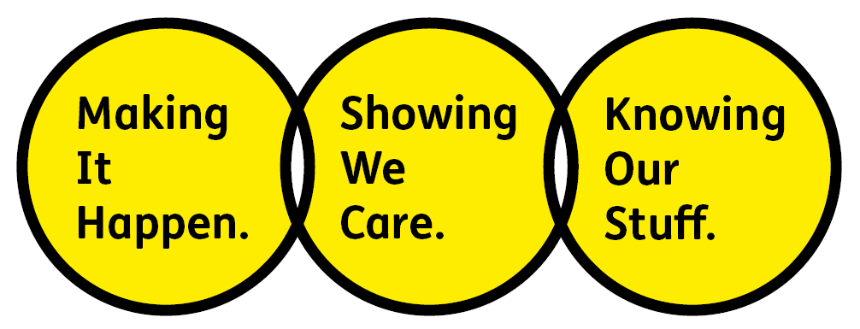
We will beat macular disease by…

Making It Happen - we are Ambitious

Showing We Care - we are Supportive and Caring
- Knowing Our Stuff - we have Integrity and we act Honestly

About the role

- Work closely with content and creative colleagues to ensure everyone is supported, engaged and equipped to deliver against agreed priorities and objectives.
- Lead the planning, coordination and delivery of content and creative projects across multiple campaigns from stakeholders across the organisation; liaising across teams and agreeing deliverables.
- Manage content production workflows, ensuring projects are delivered on time, within budget and to a high standard.
- Oversee the creative pipeline from briefing through to final delivery, balancing competing priorities and deadlines; supporting our content and creative managers in scheduling and delivering work.
- Collaborate with internal teams, agencies, freelancers and suppliers to ensure effective campaign execution and managing and resulting challenges.
- Drive consistency in brand messaging, visual identity and content quality across all channels.
- Develop and maintain processes, tools and systems that improve team efficiency, transparency and project management.
- Lead and manage content calendars, production schedules and approvals matrices, ensuring alignment with organisational objectives.
- Monitor and oversee creative and content delivery, using data and insight to inform future planning and optimisation.
- Champion best practice in content operations, digital marketing and creative project management.
- Support the development of a collaborative, innovative and high-performing creative culture.
All our team members are expected to comply with Macular Society terms and conditions, rules, policies, procedures, codes of conduct, quality standards, authorisation processes, risk management policies and relevant external regulations.

About you
1. You will be committed to equality, diversity and inclusion in all aspects of our work.
2. Have an open and collaborative approach to work, helping us to achieve our Knowing Our Stuff value by working with integrity, making informed decisions to be the best we can be to Beat Macular Disease.
3. Be able to act with empathy, providing a caring, approachable and supportive environment for all – we Show We Care by listening to each other and working together.
4. Be ambitious in your approach to help Make Things Happen, we are progressive yet supportive, and brave in our actions to make the progress that is needed to Beat Macular Disease.
5. Be happy to work in an organisation that puts those we support first, advocate for the Macular Society at all times, and be comfortable that all members of the team are part of our fundraising culture.

Specifically for this role you will have:
Knowing Our Stuff
- Strong knowledge of content marketing, creative production processes and multi-channel campaign delivery.
- Understanding of brand management, audience engagement and content performance measurement.
- Proficiency in project management and collaboration tools, with the ability to manage complex workflows effectively and understand the bigger picture.

Making It Happen
- Experience managing content and creative projects from initial brief through to delivery and evaluation.
- Proven ability to coordinate multiple stakeholders, suppliers and competing priorities in a fast-paced environment.
- Experience implementing and improving operational processes that increase efficiency, quality and team effectiveness.
- Understanding what works for specific audience groups.

Showing We Care
- Excellent organisational skills with strong attention to detail and a proactive, diplomatic approach to problem-solving.
- Strong communication and relationship-building skills, with the ability to confidently influence and collaborate at all levels.
- A positive, adaptable and supportive team player who is committed to delivering high-quality work and continuous improvement.
- Putting the needs of our audiences at the heart of our planning and content creation.

You may also have these qualities, but these are not essential:
- Experience working for a medium sized charity.
- Experience with Microsoft Dynamics 365.
- Knowledge of, or empathy with, issues related to sight loss.

Eligibility to work in the UK:
Proof of identity and eligibility to work in the UK.

Volunteering:
From time to time you may be asked to support / volunteer your time (TOIL available) at Macular Society events that take place outside of normal working hours.

Safeguarding:
The Macular Society is committed to safeguarding and promoting the welfare of all children, young people and vulnerable adults with whom we work. We expect all of our employees and volunteers to demonstrate this commitment.
You are required to carry out other such duties as may reasonably be required, relevant to the role.
This job description is accurate as at the date shown below. In consultation with you it is liable to variation by the Macular Society to reflect or anticipate changes in or to the role.

Annual leave: 27 days plus bank holidays (pro rata for part time)
Based: Andover or Hybrid with travel to Andover
Contract Type: Permanent

Date of evaluation: September 2026

